Customer Engagement
& Product Utilization
Analytics for Retention Strategy
Research Paper
Prepared from the completed Customer Engagement & Product Utilization Analytics for Retention Strategy.
Student: Iram
Domain: Financial Analyst
Context: Unified Mentor


Abstract
Customer retention has become an important concern for banking institutions as customer churn can negatively affect long-term customer relationships and business performance. This study focuses on analyzing customer engagement and product utilization to identify customers who are more likely to leave a banking institution. The study uses a European banking customer dataset consisting of 10,000 customer records and 14 variables, covering demographic, financial, behavioral, and product-related characteristics. Exploratory data analysis was conducted to examine patterns in customer activity, product ownership, geography, age, balance, credit score, and other relevant factors associated with customer churn.
Two machine learning models, Logistic Regression and Random Forest, were developed and evaluated for churn prediction. Random Forest demonstrated stronger overall predictive performance, achieving an accuracy of 86.15% and ROC-AUC of 85.53%, compared with 80.80% accuracy and 77.48% ROC-AUC for Logistic Regression. Since identifying potential churners is important for retention planning, threshold analysis was further performed. At a 0.30 prediction threshold, the Random Forest model achieved 65.11% recall and 62.13% F1-score, improving its ability to identify customers at risk of churn.
The analysis further identified age, balance, estimated salary, credit score, and number of products as important features in the Random Forest model, while customer activity showed a notable relationship with observed churn. Based on predicted churn probabilities, customers were classified into low-, medium-, and high-risk segments, with 160 customers identified as high risk within the 2,000-customer test set. The findings provide a practical basis for prioritizing retention efforts, particularly through customer re-engagement and targeted risk-based interventions. A Power BI dashboard was also developed to present the findings in an interactive and decision-oriented format.
Keywords: Customer Retention, Customer Churn, Customer Engagement, Product Utilization, Machine Learning, Random Forest, Logistic Regression, Risk Segmentation, Banking Analytics, Predictive Analytics.
Introduction
Customer retention has become an important area of concern for banking institutions because maintaining existing customer relationships is generally more sustainable than relying only on acquiring new customers. In the banking sector, customers interact with institutions through multiple products and services, and their continued relationship can be influenced by factors such as engagement, product utilization, financial characteristics, demographic attributes, and the overall depth of their relationship with the bank. Identifying customers who may be at risk of leaving can therefore help banks take timely and more focused retention actions.
The present study examines customer engagement and product utilization in relation to customer churn using a European banking customer dataset containing 10,000 observations and 14 variables. The dataset includes information on credit score, geography, gender, age, tenure, account balance, number of products, credit-card ownership, active membership, estimated salary, and customer exit status. In the dataset, 7,963 customers (79.63%) were retained, while 2,037 customers (20.37%) had exited. This indicates that although the majority of customers remained with the bank, a meaningful proportion of the customer base represented potential retention concerns.
The exploratory analysis revealed several differences in churn patterns across customer characteristics. Customer activity showed a noticeable relationship with churn, with inactive customers recording a higher churn rate than active customers. Geography also demonstrated variation, with customers from Germany showing a higher observed churn rate (32.44%) compared with France (16.15%) and Spain (16.67%). Age was another important factor, with customers in the 46–55 and 56–65 age groups showing considerably higher observed churn rates than younger customer groups. Product utilization also showed substantial differences in churn rates, particularly among customers holding three or four products; however, these groups were relatively small and therefore require cautious interpretation.
To move beyond descriptive analysis, this study applies machine learning techniques to predict customer churn. Logistic Regression was used as a baseline classification model, while Random Forest was employed to capture potentially non-linear relationships among customer characteristics. The Random Forest model produced stronger overall results, achieving an accuracy of 86.15% and ROC-AUC of 85.53%, compared with 80.80% accuracy and 77.48% ROC-AUC for Logistic Regression. Since correctly identifying potential churners is particularly relevant to retention strategy, probability-threshold analysis was also performed. At a threshold of 0.30, the Random Forest model achieved a recall of 65.11% and an F1-score of 62.13%, providing a more suitable balance for identifying customers with higher churn risk.
The study further develops a customer risk segmentation framework based on predicted churn probability. Within the 2,000 customers in the test set, 160 were classified as high risk, 275 as medium risk, and 1,565 as low risk. The high-risk segment was examined in greater detail to understand its characteristics and support practical retention planning. Finally, a Power BI dashboard was developed to communicate the major findings through customer risk distributions and high-risk customer profiles.
Overall, the study aims to demonstrate how customer engagement, product utilization, exploratory analytics, and machine learning can be combined to support a more targeted approach to customer retention in banking. Rather than treating all customers equally, the proposed approach provides a basis for prioritizing customers according to their predicted risk and developing data-driven retention strategies.

Problem Statement
Customer churn is a significant challenge for banking institutions because the loss of existing customers can weaken long-term customer relationships and reduce opportunities for continued product utilization. Although banks collect substantial amounts of customer information, identifying which customers are more likely to leave and understanding the behavioral factors associated with churn remains a practical analytical challenge.
The dataset used in this study contains 10,000 customer records and 14 variables, including demographic characteristics, financial information, product usage, customer activity, and exit status. The data shows that 2,037 customers (20.37%) had exited, indicating a meaningful level of customer attrition. However, churn is not distributed equally across all customer groups. The exploratory analysis identified differences according to customer activity, geography, age, product utilization, and other characteristics. For example, inactive customers showed higher observed churn than active customers, while customers from Germany recorded a substantially higher churn rate than customers from France and Spain.
A further challenge is that individual customer characteristics do not provide a complete basis for identifying future churn risk. Therefore, there is a need to develop a predictive approach that can combine multiple customer attributes and estimate the likelihood of customer exit. At the same time, a model with high overall accuracy may not necessarily identify a sufficient proportion of actual churners, particularly when retained customers form the majority of the dataset.
The problem addressed by this study is therefore to develop a data-driven and machine-learning-based framework that can identify customers at higher risk of churn by analysing customer engagement, product utilization, demographic, and financial characteristics. The study also seeks to segment customers according to their predicted churn probability and translate these findings into practical retention strategies. This approach can help shift retention efforts from a broad, one-size-fits-all approach towards more focused risk-based customer engagement.
Objectives of the Study
The main objective of this study is to analyze customer engagement and product utilization patterns and use machine learning techniques to identify customers who are at a higher risk of churn. The specific objectives of the study are:
- To analyze customer churn patterns using demographic, financial, behavioral, and product-related characteristics.
- To examine the relationship between customer engagement and churn, particularly by comparing active and inactive customers.
- To investigate product utilization patterns and assess how the number of products held by customers is associated with customer retention and churn.
- To identify important customer characteristics associated with churn risk, including age, balance, credit score, estimated salary, geography, tenure, and product usage.
- To develop and compare machine learning models for predicting customer churn using Logistic Regression and Random Forest.
- To evaluate model performance using accuracy, precision, recall, F1-score, and ROC-AUC, with particular attention to the model's ability to identify potential churners.
- To segment customers according to their predicted churn probability into low-, medium-, and high-risk categories.
- To develop data-driven retention strategies that can help banks prioritize high-risk customers, improve engagement, and support more targeted customer retention initiatives.
- To develop an interactive Power BI dashboard for presenting customer risk patterns and supporting managerial decision-making.

Literature Review
Customer churn prediction has received considerable attention in banking because early identification of customers who may leave can help financial institutions take preventive retention measures. Earlier research established the usefulness of machine-learning techniques for predicting customer retention and churn. For example, Xie et al. investigated customer churn prediction using Random Forest and specifically addressed the problem of imbalanced churn data through balanced and cost-sensitive learning approaches. Their findings demonstrated the importance of considering the minority churn class rather than relying only on overall prediction accuracy.
The application of machine learning to banking churn has subsequently expanded. A study published through IEEE compared techniques including K-Nearest Neighbors, Support Vector Machines, Decision Trees, and Random Forest using a bank churn dataset. The study reported that Random Forest performed particularly well after addressing class imbalance, supporting the use of ensemble-based methods for customer churn prediction.
Research has also emphasized the importance of comparing different machine-learning algorithms rather than relying on a single predictive model. A 2023 study on customer churning evaluated Random Forest, Logistic Regression, KNN, and stochastic gradient boosting. The study highlighted the value of comparing alternative classification techniques to determine which approach provides the most suitable predictive performance for churn management. Similarly, more recent research comparing traditional and ensemble approaches found that ensemble methods such as Random Forest and XGBoost can outperform conventional classifiers on several predictive performance measures.
The banking literature also increasingly connects churn prediction with practical decision-making and visualization. A 2024 study specifically examined bank customer churn using multiple machine-learning algorithms and developed a visualization application to help managers interpret churn patterns. The research argued that predictive analysis can help banks identify customers who are approaching attrition and support targeted retention actions. Another 2024 study proposed a machine-learning-based churn management system and reported Random Forest as the best-performing classifier among the models evaluated, illustrating the practical potential of predictive churn systems in banking.
Another important area of research is model interpretability. High predictive accuracy alone may not be sufficient for managerial applications because banks also need to understand why customers are being classified as high risk. A study on explainable machine learning for bank churn emphasized the importance of combining ensemble models with interpretation techniques such as feature importance and SHAP values. It also highlighted the relevance of appropriate preprocessing and methods for addressing class imbalance in bank churn datasets. More recent research has similarly emphasized probability reliability and explainability, arguing that churn probabilities should be sufficiently trustworthy for practical decision-making rather than focusing only on classification accuracy.
Recent research continues to demonstrate the importance of customer characteristics such as age and product holdings in churn modelling. A 2026 study examining joint churn and product-down sell prediction identified age, account balance, and product holdings among the important churn-related predictors. This is particularly relevant to the present study because product utilization and customer characteristics are central components of the proposed retention framework.
Research Gap
Although previous studies demonstrate the effectiveness of machine learning for customer churn prediction, several gaps remain relevant to practical retention management. Many studies primarily focus on maximizing predictive performance, while less attention is given to converting predicted probabilities into actionable customer-risk segments. In addition, overall accuracy can provide an incomplete picture when churn represents the minority class. Therefore, measures such as recall and F1-score are particularly important when the objective is to identify customers who may leave.
The present study addresses this gap by combining exploratory customer analysis, Logistic Regression, Random Forest, ROC-AUC evaluation, probability-threshold analysis, and customer risk segmentation. Rather than selecting a model solely on the basis of accuracy, the study examines the ability of the model to identify potential churners and uses a lower prediction threshold to improve churn recall. The study further translates the predicted probabilities into low-, medium-, and high-risk customer groups and connects these segments with practical retention recommendations. This provides a more decision-oriented framework for using machine learning in customer retention.
Key references for your paper
- Xie, Y., Li, X., Ngai, E. W. T., & Ying, W. (2009). Customer churn prediction using improved balanced random forests. Expert Systems with Applications, 36(3), 5445–5449.
- Machine Learning Based Customer Churn Prediction In Banking. (2020). 4th International Conference on Electronics, Communication and Aerospace Technology (ICECA). IEEE.
- Customer churning analysis using machine learning algorithms. (2023). International Journal of Intelligent Networks, 4, 145–154.
- Investigating customer churn in banking: A machine learning approach and visualization app for data science and management. (2024). Data Science and Management, 7(1), 7–16.
- Smart Customer Churn Management System Using Machine Learning. (2024). Procedia Computer Science, 237, 552–558.
- Improving Churn Detection in the Banking Sector: A Machine Learning Approach with Probability Calibration Techniques. (2024). Electronics, 13(22), 4527.
- Enhancing customer retention with machine learning: A comparative analysis of ensemble models for accurate churn prediction. (2025). International Journal of Information Management Data Insights, 5(1), 100331

Dataset and Variables
Dataset Description
The study uses a European banking customer dataset containing 10,000 customer observations and 14 variables. The dataset provides information related to customers' demographic characteristics, financial position, banking product utilization, account activity, and customer exit status. These variables provide a basis for examining customer behavior and identifying patterns associated with customer churn.
The dependent variable in the study is Exited, which indicates whether a customer has left the bank. A value of 0 represents a retained customer, whereas 1 represents a churned customer. In the complete dataset, 7,963 customers were retained and 2,037 customers had exited, corresponding to an overall churn rate of 20.37%.
Variable | Description | Role
Year | Year associated with the customer record | Removed
Customer Id | Unique customer identifier | Identifier
Surname | Customer surname | Identifier
Credit Score | Customer credit score | Predictor
Geography | Customer's geographical location | Predictor
Gender | Customer gender | Predictor
Age | Customer age | Predictor
Tenure | Number of years associated with the bank | Predictor
Balance | Customer account balance | Predictor
NumOfProducts | Number of banking products held | Predictor
Has Cr Card | Indicates whether the customer has a credit card | Predictor
Is Active Member | Indicates whether the customer is an active bank member | Predictor
Estimated Salary | Estimated customer salary | Predictor
 | Indicates customer churn/exit | Target
Variables Used in the Study

Data Preparation
Before developing the predictive models, the dataset was examined for data quality and consistency. The analysis found no missing values and no duplicate records. The Year variable contained a constant value and therefore did not provide useful variation for prediction. Customer Id and Surname were treated as identification variables rather than behavioral or financial predictors and were excluded from model development.
Categorical variables, particularly Geography and Gender, were converted into numerical form using one-hot encoding. This produced 11 model features, with France and Female serving as the reference categories. The data was then divided into 80% training data and 20% testing data using stratified sampling with random state = 42, maintaining the proportion of churned and retained customers in both datasets.
For Logistic Regression, the numerical features were standardized using Standard Scaler. Random Forest was trained using the original encoded features and a balanced class-weight setting to improve its treatment of the minority churn class.
5.4 Target Variable Distribution
The target variable indicates that the dataset is imbalanced:
- Retained customers: 7,963 (79.63%)
- Churned customers: 2,037 (20.37%)
This imbalance was considered during model evaluation. Therefore, the study did not rely solely on accuracy and also examined precision, recall, F1-score, and ROC-AUC, with particular attention to recall for identifying potential churners.
Research Methodology
The study follows a structured data analytics and machine learning approach to examine customer churn and identify customers who may require retention interventions. The methodology consists of data preparation, exploratory analysis, feature preparation, model development, model evaluation, churn-risk segmentation, and dashboard development.
1. Data Preprocessing
The analysis began with an assessment of the dataset structure, data types, missing values, duplicate records, and the uniqueness of categorical variables. The dataset contained 10,000 customer records and 14 variables. No missing values or duplicate records were identified. The Year variable contained a constant value and was therefore excluded from further analysis. Customer Id and Surname were also removed from model development because they function as identification variables rather than meaningful behavioral or financial predictors.
The target variable, Exited, was retained as the dependent variable, where 0 represents customers who remained with the bank and 1 represents customers who exited.
2. Exploratory Data Analysis
Exploratory Data Analysis (EDA) was performed to understand the distribution of customer characteristics and identify patterns associated with churn. The analysis examined customer activity, number of products, geography, gender, age, tenure, account balance, estimated salary, credit score, and credit-card ownership.
Cross-sectional analyses were also performed to examine interactions between variables. These included activity and product utilization, geography and activity, gender and activity, balance and activity, product utilization and gender, product utilization and geography, and age group and activity. Churn rates were calculated for relevant customer groups to identify segments with comparatively higher observed churn.
A correlation analysis was also conducted to examine the relationship between numerical variables and the target variable. The analysis indicated that Age had the strongest positive correlation with Exited among the examined numerical variables, while Is Active Member showed a notable negative correlation.
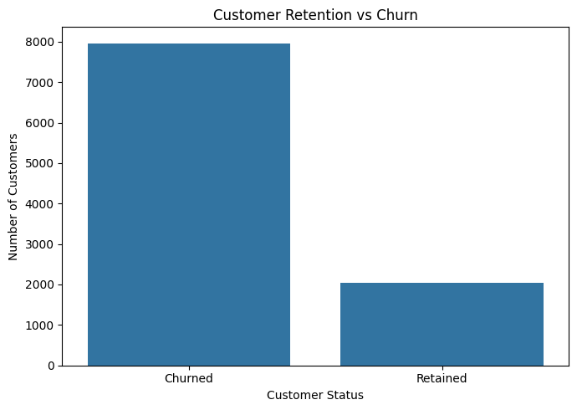
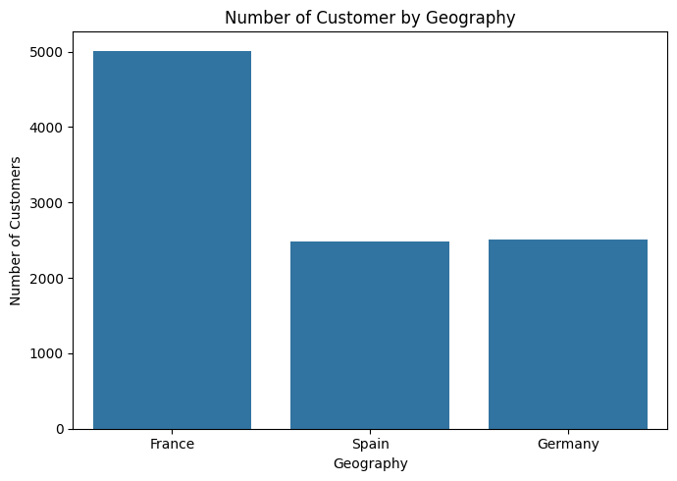
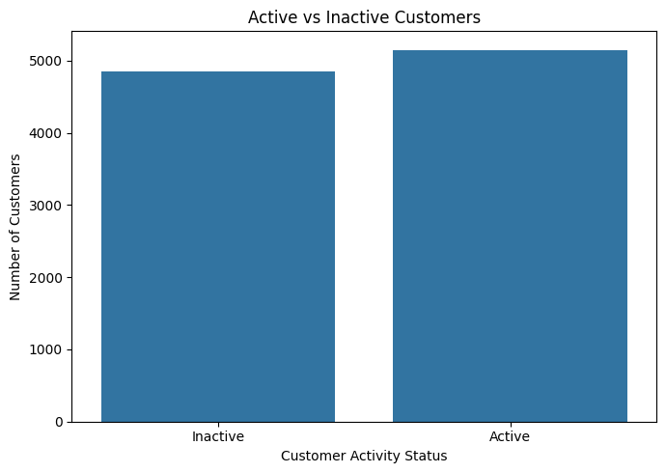

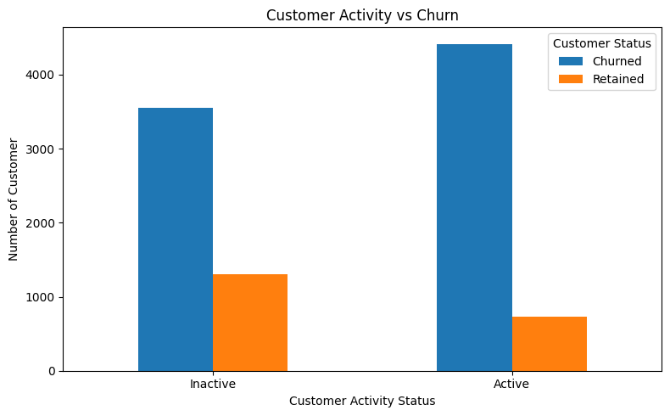
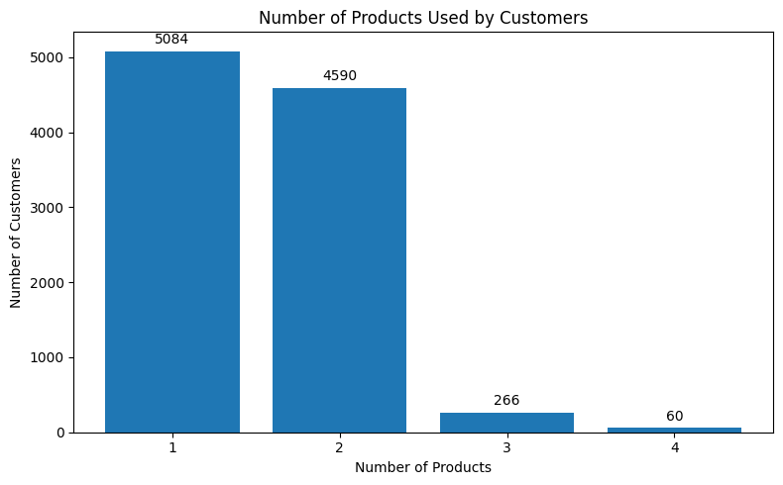

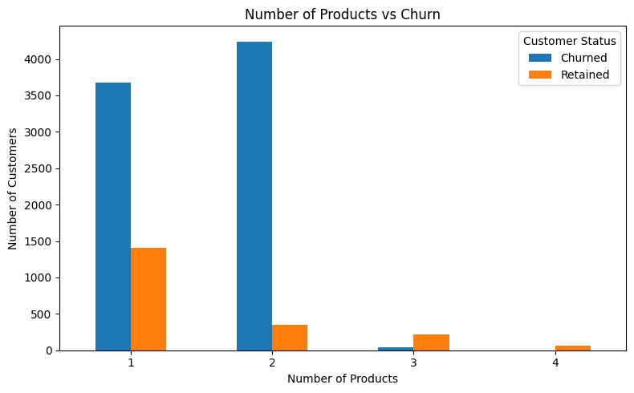

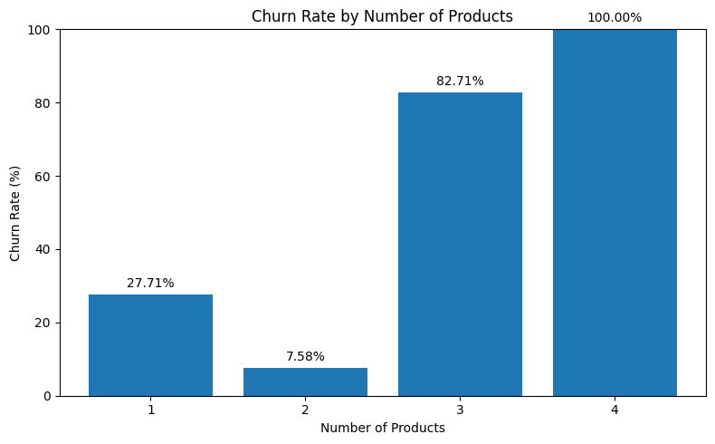

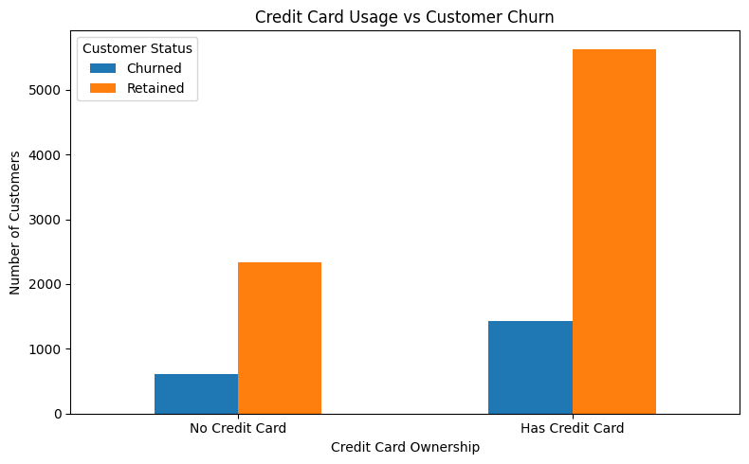

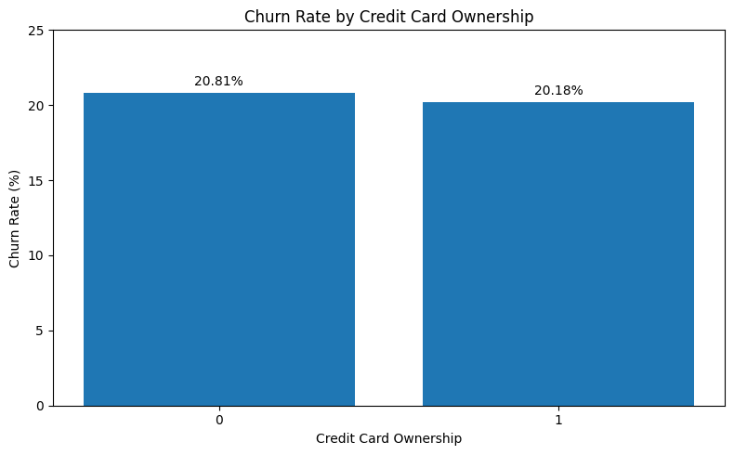

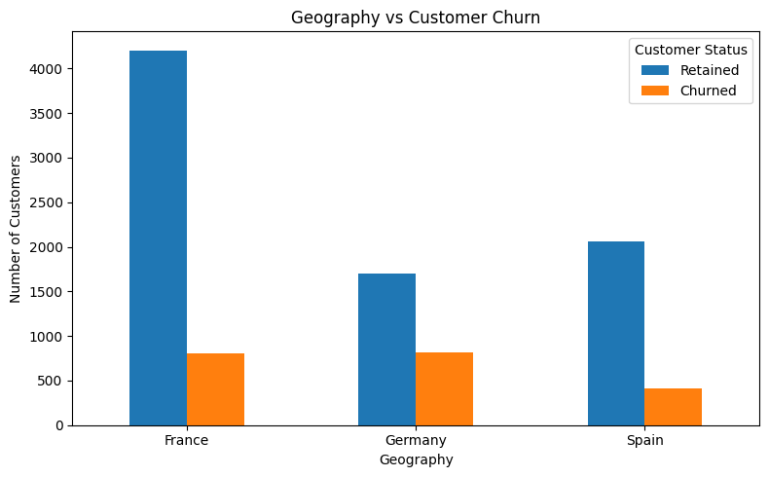

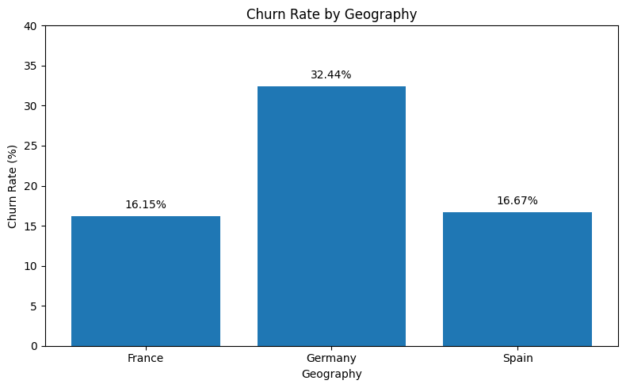

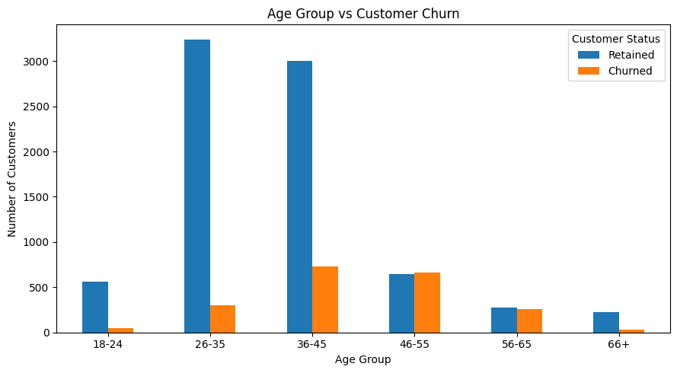

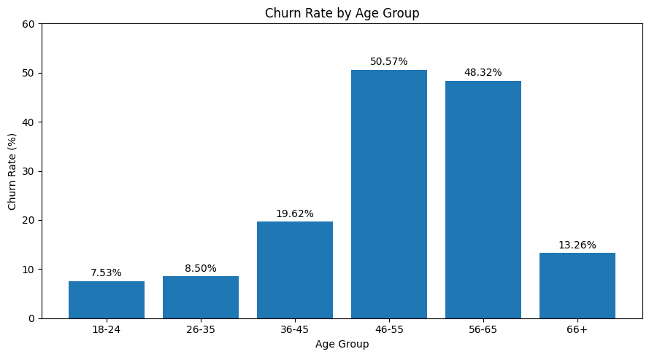

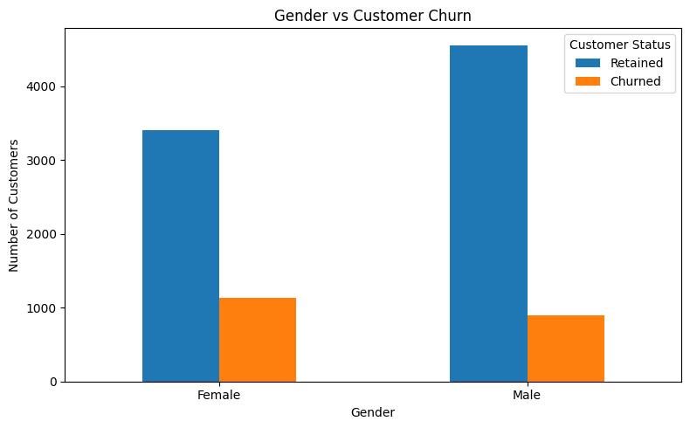

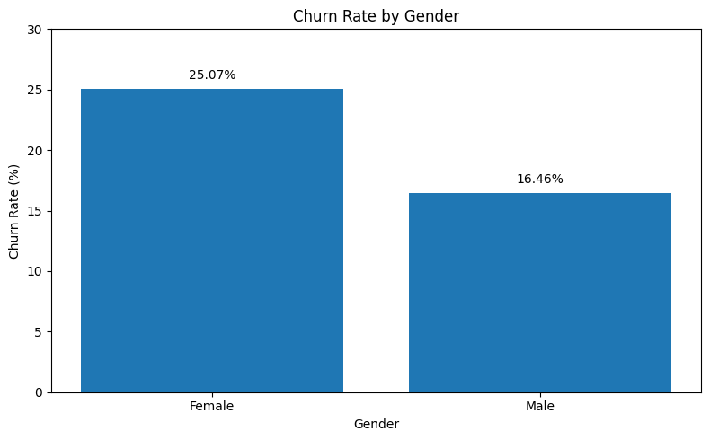

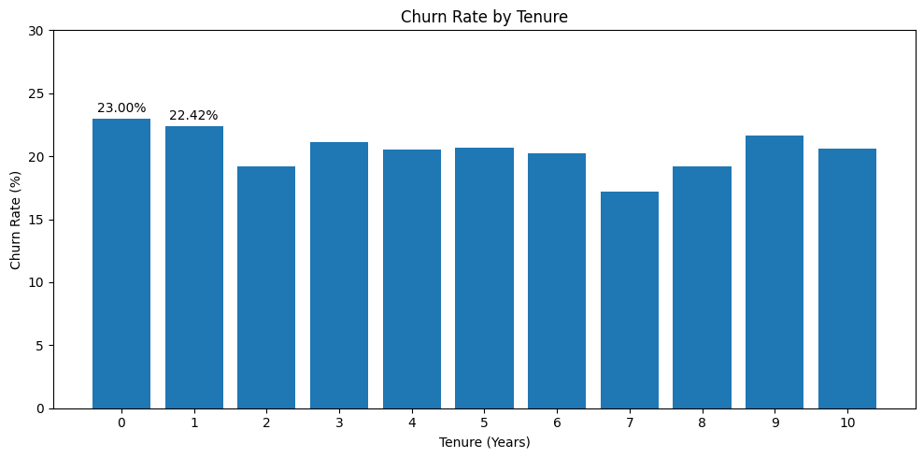

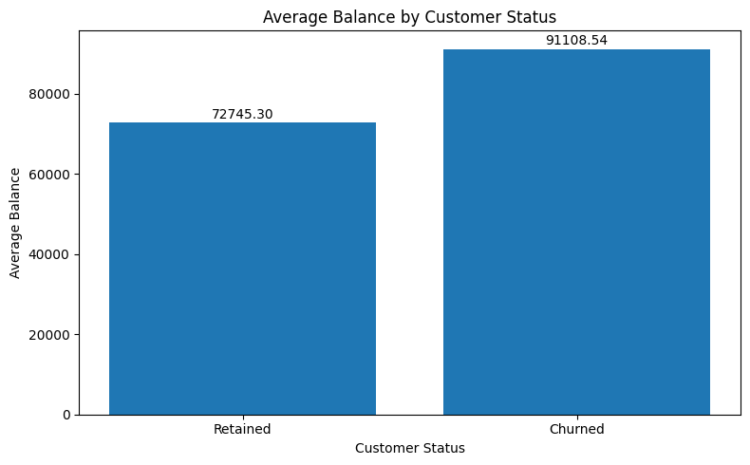

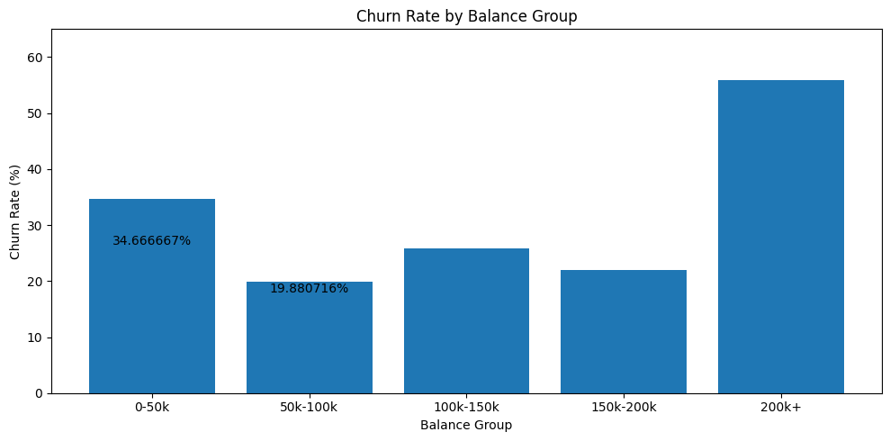

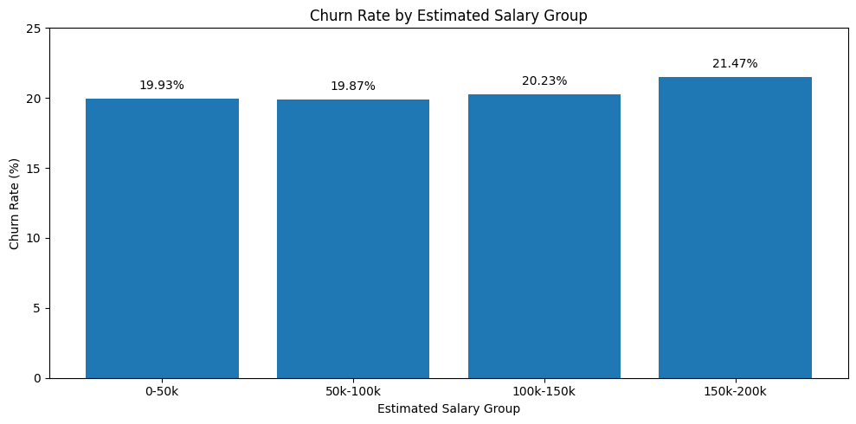

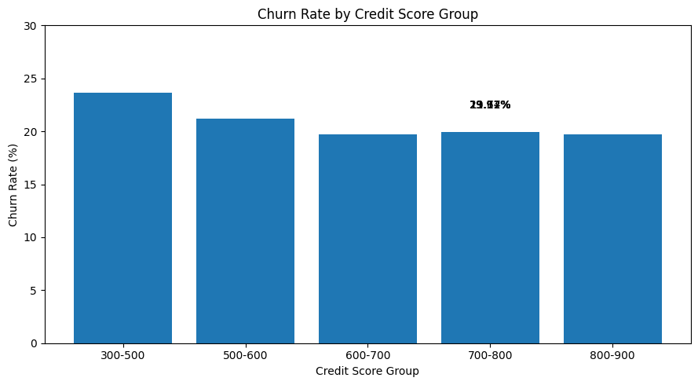
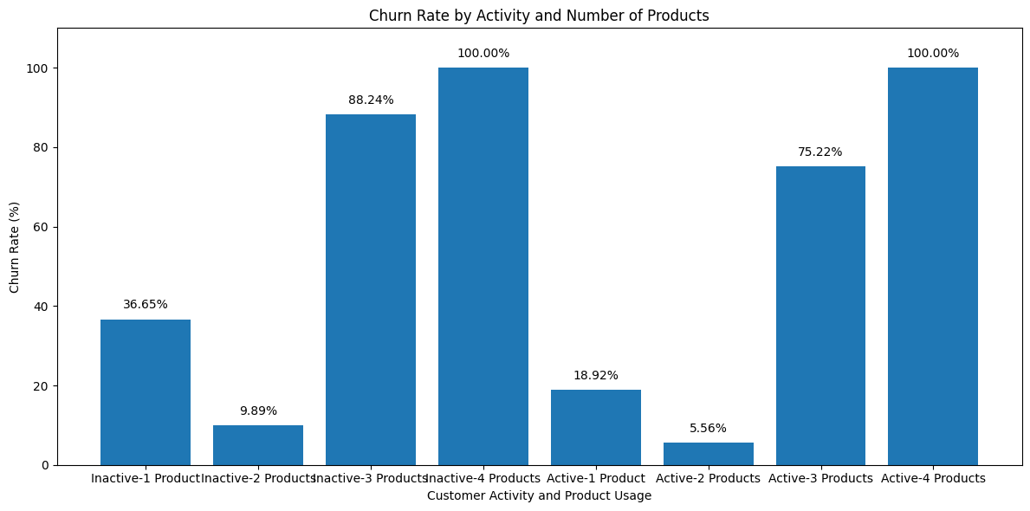

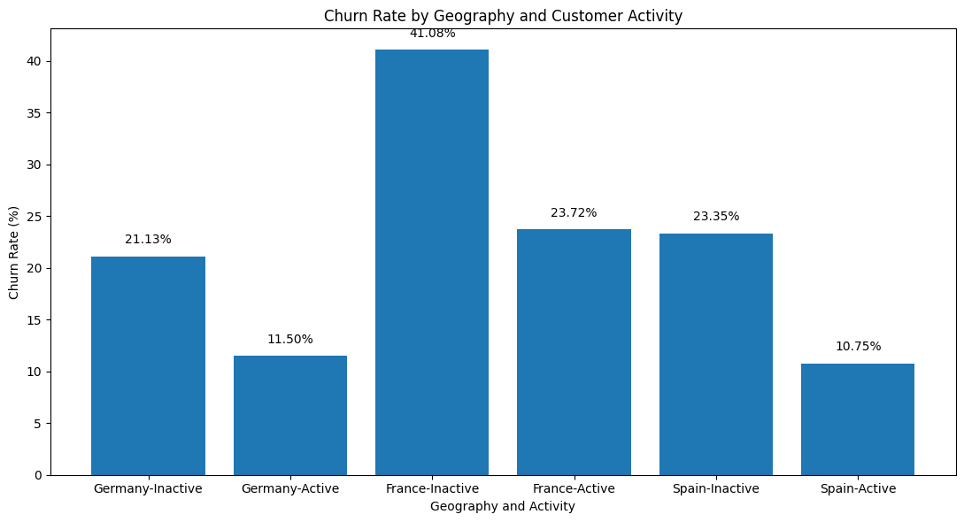

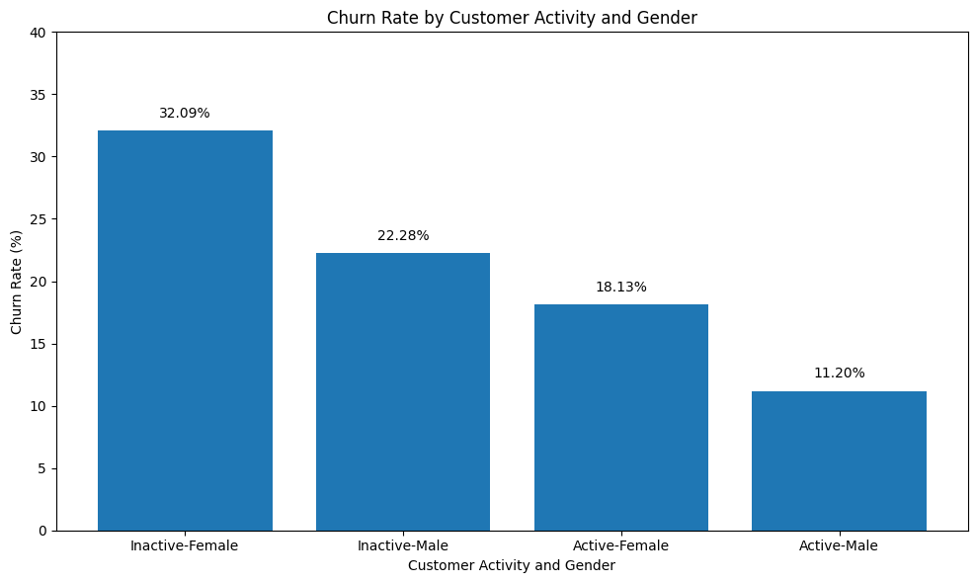

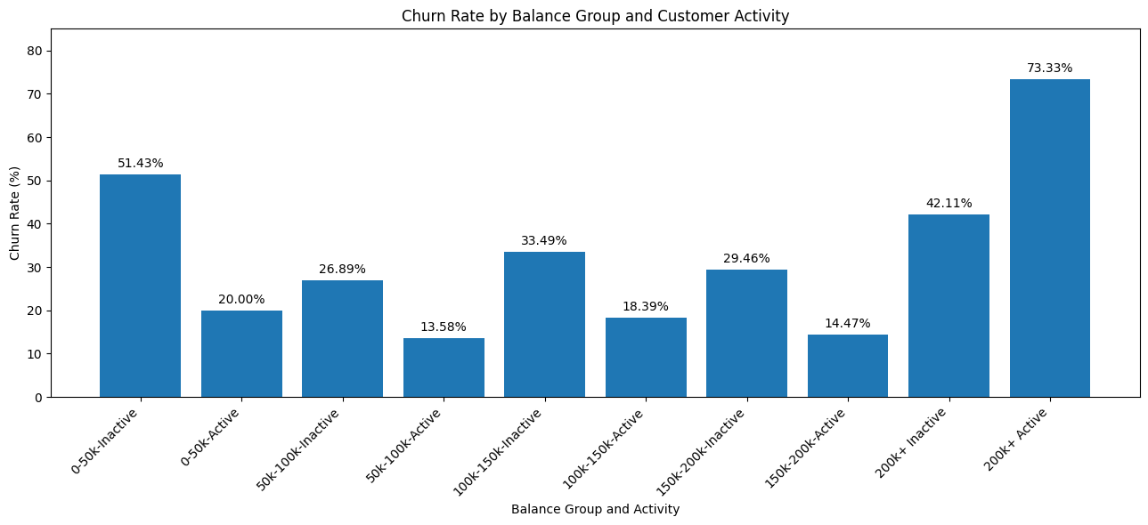

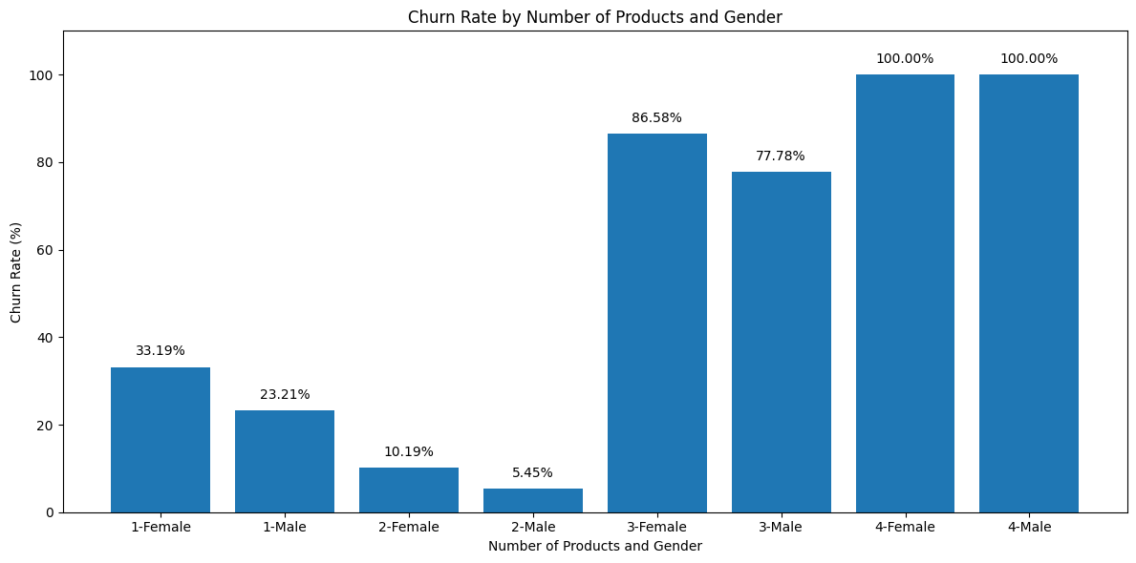
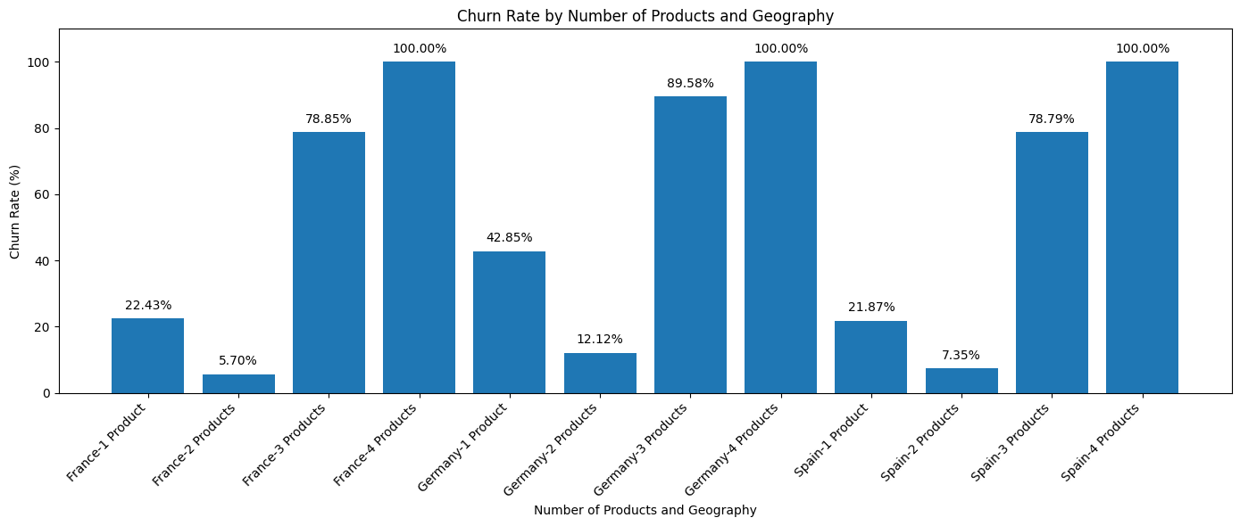
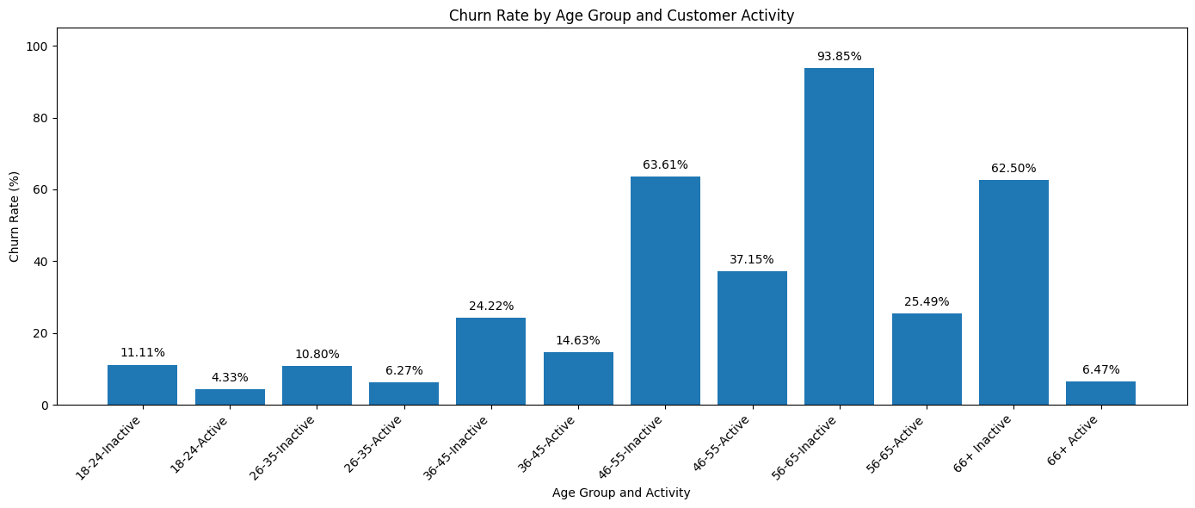
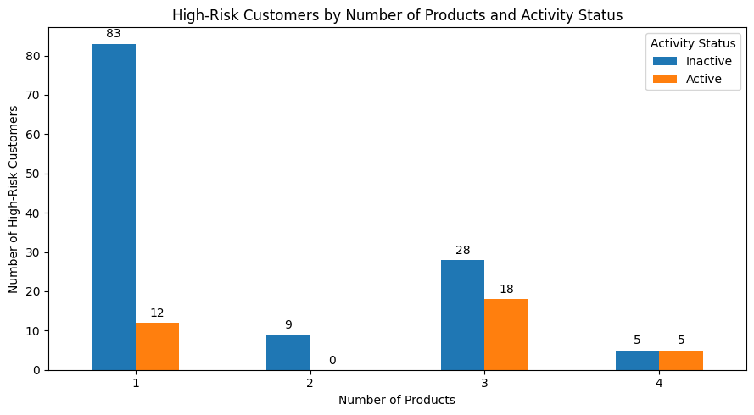

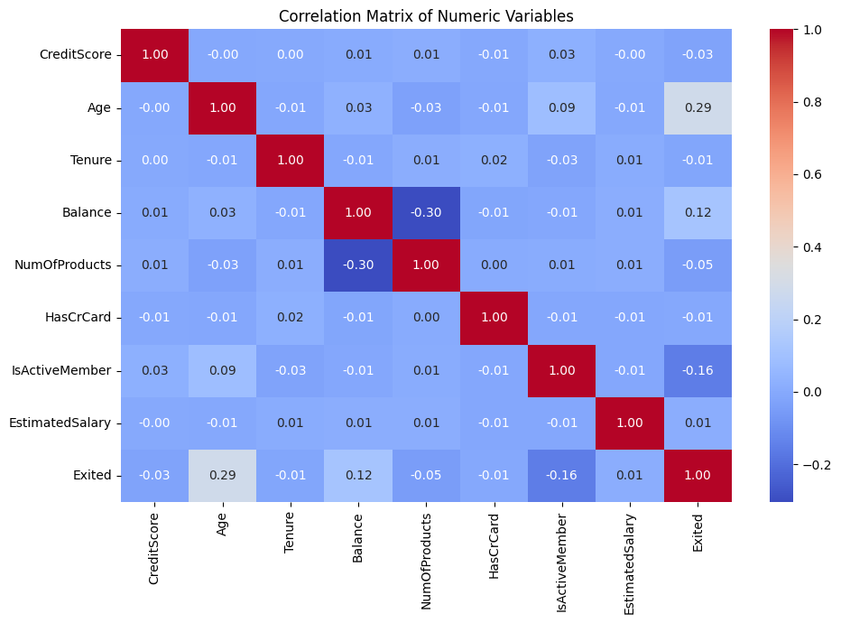

3. Feature Preparation
After the EDA stage, EDA-specific grouping variables were excluded from the final modelling dataset to avoid incorporating analysis-only transformations into the predictive model. The modelling dataset consisted of 10 predictor variables and one target variable.
The categorical variables Geography and Gender were transformed using one-hot encoding. This generated 11 model features, including the encoded geographical and gender categories. France and Female were used as reference categories.
The data was divided into training and testing subsets using an 80:20 train-test split. Stratified sampling was applied so that the relative distribution of retained and churned customers was maintained in both subsets. A random state of 42 was used to ensure reproducibility.
4. Logistic Regression Model
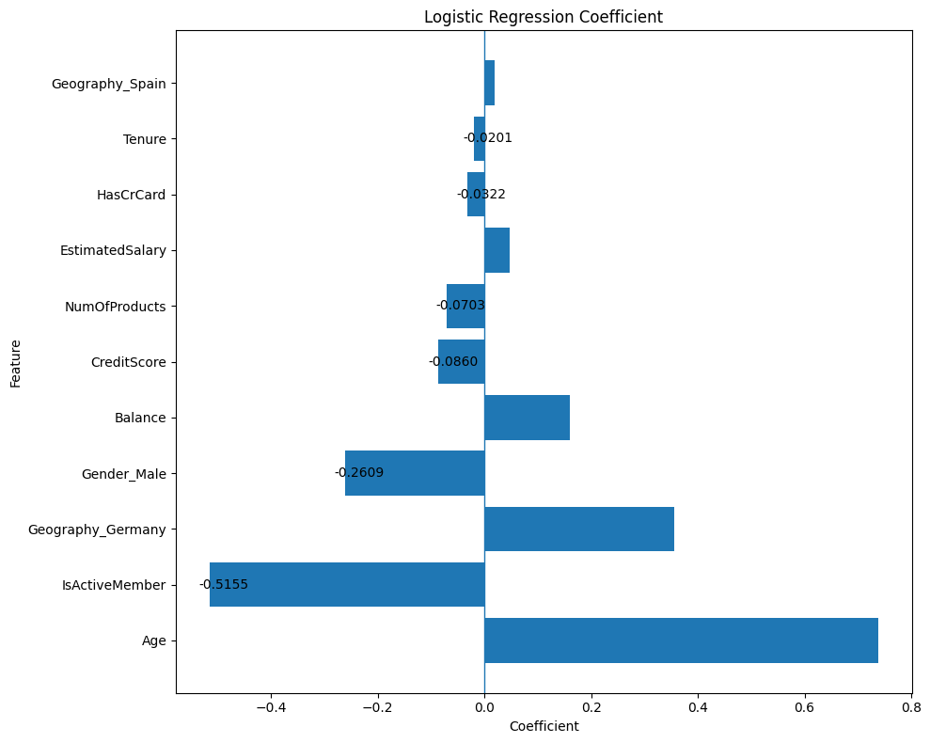
Logistic Regression was developed as the baseline classification model. Since Logistic Regression is sensitive to the scale of numerical variables, the predictor variables were standardized using Standard Scaler before model training.
The model was trained on the scaled training data and subsequently used to predict customer churn probabilities and class labels for the test dataset. Logistic Regression provided a baseline against which the performance of the Random Forest model could be compared.
5. Random Forest Model
A Random Forest Classifier was developed as the primary machine learning model. The model consisted of 200 decision trees and used a fixed random state of 42. The class weight='balanced' setting was applied to give greater consideration to the minority churn class.
Random Forest was selected because it can capture non-linear relationships and interactions among customer characteristics without requiring the same linear assumptions as Logistic Regression. The model was trained using the unscaled encoded features and evaluated on the held-out test dataset.
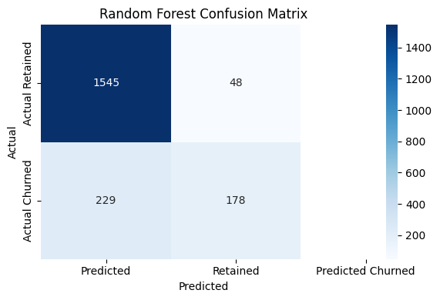

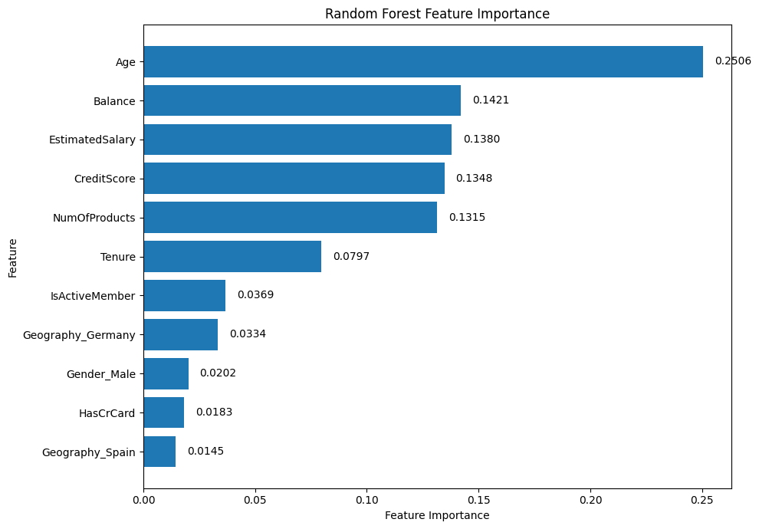

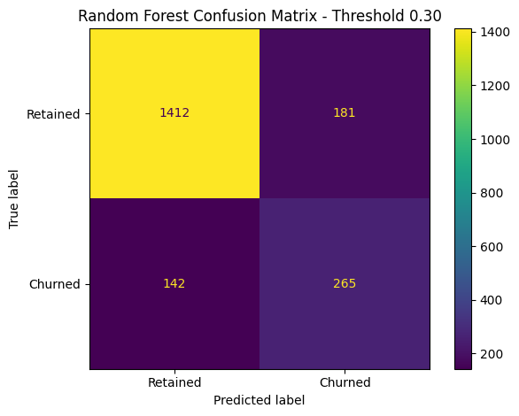
6. Model Evaluation
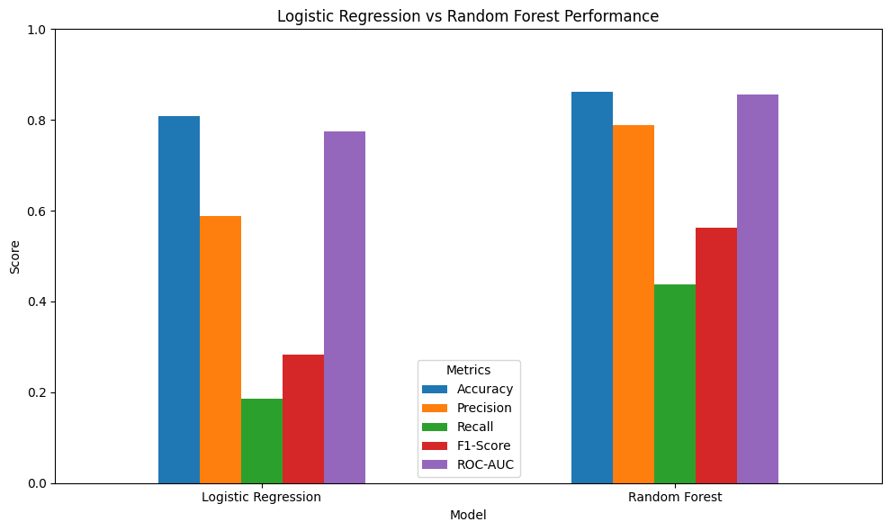
The two models were evaluated using multiple performance measures rather than accuracy alone. The evaluation included:
- Accuracy: proportion of all predictions classified correctly.
- Precision: proportion of customers predicted as churners who actually churned.
- Recall: proportion of actual churners successfully identified by the model.
- F1-score: harmonic mean of precision and recall.
- ROC-AUC: measures the model's ability to distinguish between retained and churned customers across different classification thresholds.
This multi-metric evaluation was particularly important because the dataset contained substantially more retained customers than churned customers. Consequently, a model could achieve relatively high accuracy while still failing to identify a large proportion of actual churners.
7. Feature Importance Analysis
Feature importance was examined for the Random Forest model to determine which variables contributed most strongly to its predictive decisions. The analysis identified Age, Balance, Estimated Salary, Credit Score, and NumOfProducts among the most important features.
Logistic Regression coefficients were also examined to understand the direction of association represented by the baseline model. These results were used as interpretive evidence rather than as proof of causal relationships.
8. Prediction Threshold Optimization
The default classification threshold of 0.50 was further examined because the primary objective of the study was to identify customers who may be at risk of churn. Several probability thresholds were evaluated to understand the trade-off between precision and recall.
The tested thresholds included 0.30, 0.40, 0.50, and 0.60. A threshold of 0.30 was selected because it produced the highest recall among the tested thresholds while also producing the highest F1-score in the threshold analysis. At this threshold, the Random Forest model achieved:
- Accuracy: 83.85%
- Precision: 59.42%
- Recall: 65.11%
- F1-score: 62.13%
The lower threshold therefore increased the model's ability to identify potential churners compared with the default threshold.
9. Customer Risk Segmentation
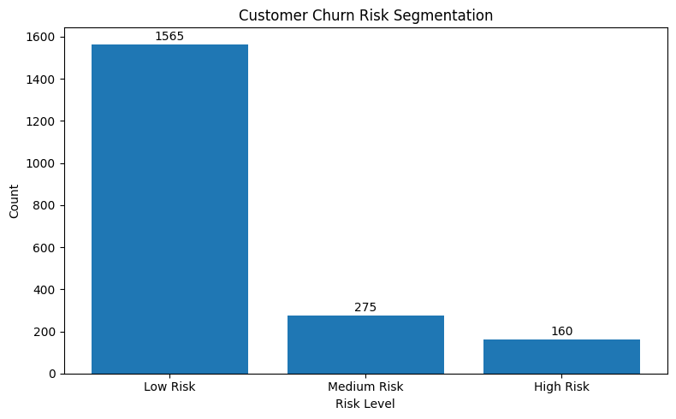
The predicted churn probabilities generated by the Random Forest model were used to classify customers into three risk categories: Low Risk, Medium Risk, and High Risk. Within the 2,000 customers in the test dataset:
- Low Risk: 1,565 customers (78.25%)
- Medium Risk: 275 customers (13.75%)
- High Risk: 160 customers (8.00%)
The high-risk segment was then analyzed according to age, geography, activity status, number of products, credit score, and balance to develop a clearer customer risk profile.
10. Dashboard Development
Finally, the analytical results were incorporated into an interactive Power BI dashboard. The dashboard was organized into three sections: Executive Overview, Risk Analysis, and Customer Risk Profile. The dashboard presents key customer-risk indicators, risk distribution, geographical patterns, product utilization, activity levels, age groups, credit scores, balance, tenure, and other high-risk customer characteristics.
The dashboard provides a visual interface through which the analytical findings can be interpreted and used to support customer-retention decision-making.

Exploratory Data Analysis Findings
Exploratory Data Analysis was conducted to understand the characteristics of the customers and identify patterns associated with customer retention and churn. The analysis considered customer activity, product utilization, geography, age, gender, tenure, balance, salary, credit score, and combinations of these variables.
1. Overall Customer Churn
The dataset contains 10,000 customers, of whom 7,963 (79.63%) were retained and 2,037 (20.37%) had exited. Thus, approximately one-fifth of the observed customer base had churned. This distribution also indicates that the target variable is imbalanced, which is important when interpreting the subsequent machine learning results.
2. Customer Activity and Churn
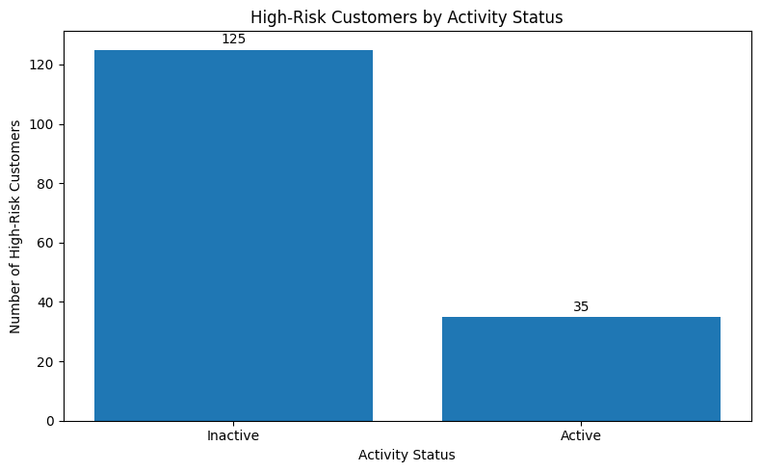
Customer activity showed a noticeable relationship with churn. Inactive customers had a churn rate of approximately 26.85%, whereas active customers had a considerably lower churn rate of 14.27%. This difference suggests that customer engagement is an important descriptive indicator of retention risk.
The interaction between activity and other characteristics reinforced this pattern. For example, among customers with one product, the observed churn rate was 36.65% for inactive customers, compared with 18.92% for active customers. Among customers with two products, the corresponding rates were 9.89% and 5.56%, respectively.
3. Product Utilization and Churn
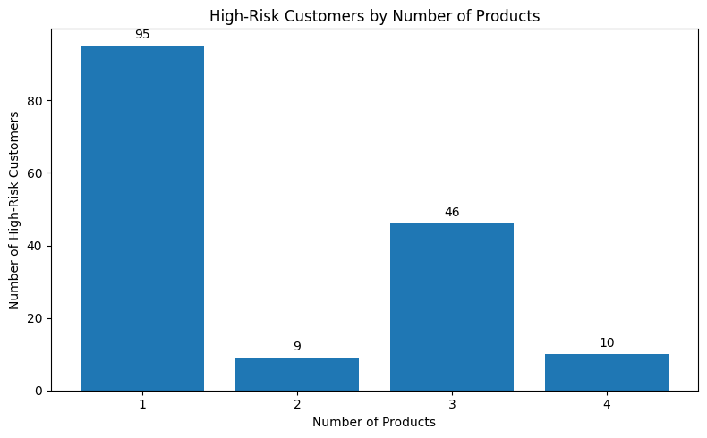
The number of banking products held by customers showed substantial variation in observed churn. Customers with one product had a churn rate of 27.71%, while customers with two products had a considerably lower rate of 7.58%.
The three- and four-product groups showed very high observed churn rates of 82.71% and 100%, respectively. However, these groups contained only 266 and 60 customers, respectively. Therefore, the unusually high churn rates in these categories should be interpreted cautiously and should not be considered evidence that holding more products directly causes churn.
4. Geographic Differences
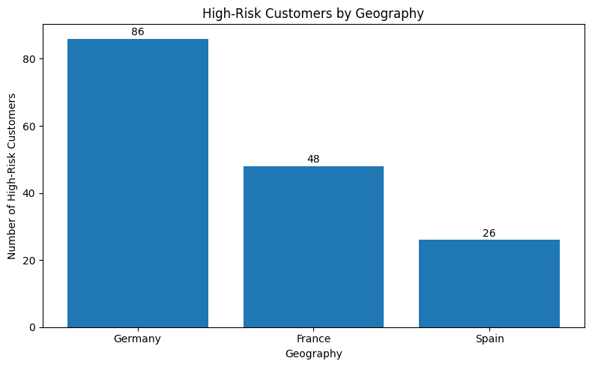
Geographical analysis revealed considerable differences in customer churn. Customers from Germany recorded the highest churn rate at 32.44%, compared with 16.15% in France and 16.67% in Spain.
The same pattern was observed when geography was analyzed together with activity. In Germany, inactive customers had an observed churn rate of 41.08%, compared with 23.72% among active customers. France and Spain also showed higher churn among inactive customers. This indicates that both geography and customer activity provide useful descriptive information for understanding churn patterns.
5. Age and Churn
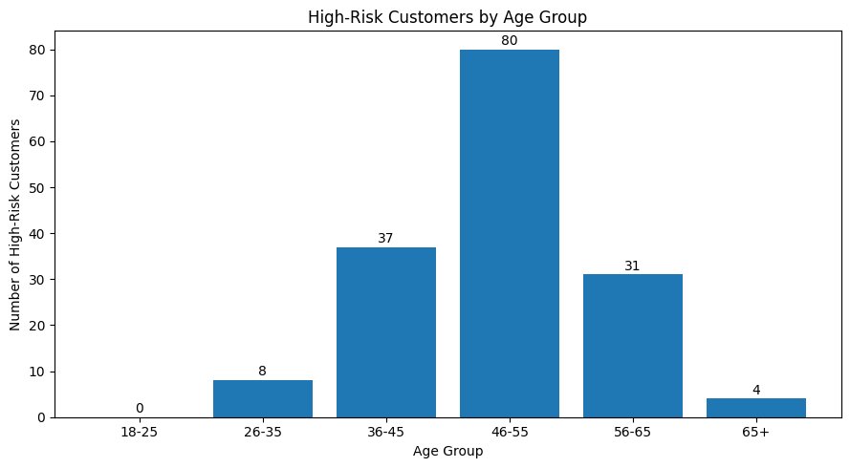
Age demonstrated one of the clearest patterns in the exploratory analysis. Customers in the 46–55 age group recorded a churn rate of 50.57%, while the 56–65 group recorded 48.32%. In comparison, the churn rates for customers aged 18–24 and 26–35 were only 7.53% and 8.50%, respectively.
The analysis of age and activity also showed that inactive customers generally had higher churn rates across age groups. The 46–55 and 56–65 groups were particularly notable for their elevated observed churn.
6. Gender and Churn
The analysis also identified a difference in observed churn between gender groups. Female customers recorded a churn rate of 25.07%, while the rate for male customers was 16.46%. When activity was considered simultaneously, the observed churn rates were 32.09% for inactive females and 22.28% for inactive males, compared with 18.13% for active females and 11.20% for active males.
These results are descriptive and should not be interpreted as evidence that gender itself causes customer churn. Gender-related differences may reflect the influence of other customer characteristics and interactions within the dataset.
7. Tenure and Churn
Tenure showed relatively limited variation in churn compared with some of the other variables. Churn rates across tenure levels ranged approximately from 17.22% to 23.00%. The highest rate was observed at tenure 0, while tenure 7 had the lowest rate.
No clear increasing or decreasing trend was observed across tenure levels. Therefore, tenure appeared to be a relatively weak standalone indicator of churn in the exploratory analysis.
8. Balance and Churn
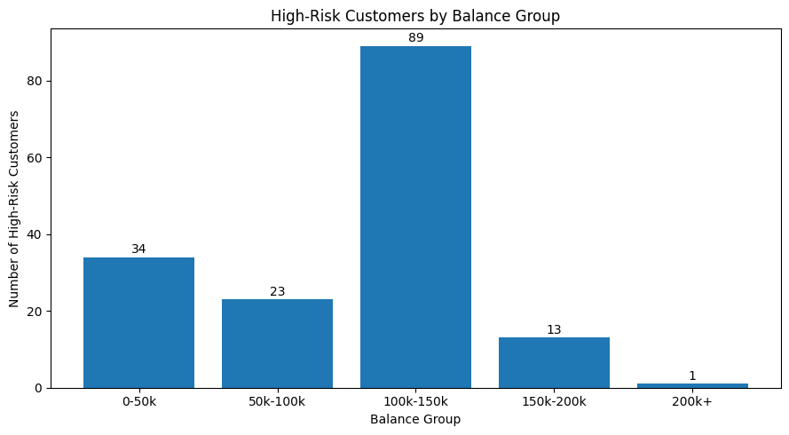
Customers who had exited the bank had a higher average balance than retained customers. The average balance was approximately 91,108.54 for churned customers, compared with 72,745.30 for retained customers.
When customers were grouped according to balance, the observed churn rates varied across categories. The 200K+ group recorded the highest rate at 55.88%, but this group contained only 34 customers. The 0–50K group also showed a comparatively high rate of 34.67%, while the remaining groups showed rates between approximately 19.88% and 25.77%. These findings indicate variation in churn across balance groups but also highlight the need to consider group size when interpreting extreme rates.
9. Estimated Salary and Credit Score
Estimated salary showed relatively small differences in churn across the four salary groups. Churn rates ranged from approximately 19.87% to 21.47%, suggesting that estimated salary was a relatively weak standalone indicator in the exploratory analysis.
Credit score also showed limited variation in churn across most groups. The 300–500 credit-score group recorded a churn rate of 23.64%, compared with approximately 19.69%–21.17% for the other groups. This indicates a somewhat higher churn rate among customers with lower credit scores, although the relationship was not particularly strong.
10. Credit Card Ownership
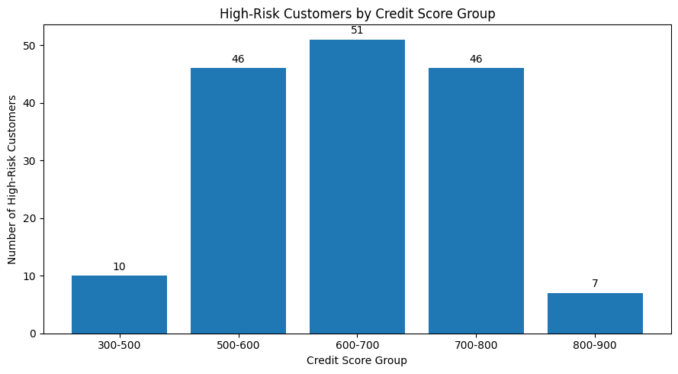
Credit-card ownership showed almost no meaningful difference in observed churn. Customers without a credit card had a churn rate of 20.81%, while customers with a credit card had a rate of 20.18%. The difference of approximately 0.63 percentage points suggests that credit-card ownership was a weak standalone indicator of customer churn in this dataset.
11. Correlation Analysis
Correlation analysis was conducted for the numerical variables against the target variable. Among the examined variables, Age showed the strongest positive correlation with Exited (0.2853), while Is Active Member showed a negative correlation of -0.1561. Balance had a smaller positive correlation of 0.1185.
The remaining variables showed relatively weak linear correlations with churn, including Estimated Salary (0.0121), Tenure (-0.0140), Credit Score (-0.0271), Has Cr Card (-0.0071), and NumOfProducts (-0.0478).
These correlation values should not be interpreted as measures of causal influence. They only describe the strength and direction of linear association between individual variables and the churn indicator.

Machine Learning Results
To assess whether customer engagement, product utilization, and other customer characteristics could be used to predict churn, two machine learning models were developed: Logistic Regression and Random Forest. Logistic Regression was used as a baseline model because it provides relatively interpretable relationships between the predictor variables and churn probability, while Random Forest was used to capture potentially non-linear relationships and interactions among customer characteristics.
The dataset was divided into 80% training data and 20% testing data using stratified sampling to maintain the proportion of retained and churned customers in both datasets. Categorical variables were converted using one-hot encoding, and numerical variables were standardized for Logistic Regression. Random Forest was trained using class weighting to give greater importance to the minority churn class.
1. Model Performance Comparison
The performance of both models was evaluated using accuracy, precision, recall, F1-score, and ROC-AUC.
Model | Accuracy | Precision | Recall | F1-Score | ROC-AUC
Logistic Regression | 80.80% | 58.91% | 18.67% | 28.36% | 77.48%
Random Forest | 86.15% | 78.76% | 43.73% | 56.24% | 85.53%

The results show that Random Forest performed better than Logistic Regression across all five evaluation metrics. Its accuracy reached 86.15%, compared with 80.80% for Logistic Regression. More importantly for churn identification, Random Forest achieved a recall of 43.73%, substantially higher than the 18.67% obtained by Logistic Regression.
The higher ROC-AUC of Random Forest (85.53%) also indicates better overall discrimination between customers who churned and those who were retained. However, the recall at the default 0.50 probability threshold remained below 50%. Therefore, relying only on the default classification threshold would result in a considerable number of churned customers being missed.
2. Logistic Regression Results
Logistic Regression achieved an accuracy of 80.80% and an ROC-AUC of 77.48%. Although the model correctly classified a large proportion of customers overall, its ability to identify churned customers was relatively weak.
The recall for the churn class was only 18.67%, meaning that many customers who actually exited were not identified by the model at the default threshold. The F1-score of 28.36% further indicates the difficulty of balancing precision and recall for the churn class.
The relatively low recall is important in a retention-focused application because correctly identifying customers who are likely to leave is more useful than simply achieving high overall classification accuracy. Therefore, Logistic Regression was retained as a baseline rather than the primary predictive model.
3. Random Forest Results
Random Forest produced stronger predictive performance, achieving 86.15% accuracy, 78.76% precision, 43.73% recall, 56.24% F1-score, and 85.53% ROC-AUC.
At the default probability threshold of 0.50, the model produced the following confusion matrix:
 | Predicted Retained | Predicted Churned
Actual Retained | 1,545 | 48
Actual Churned | 229 | 178

The model correctly identified 178 of the 407 churned customers in the test dataset. However, 229 churned customers were classified as retained, demonstrating that the default threshold was not sufficiently sensitive for a retention-oriented objective.
The results therefore suggest that Random Forest provides a stronger foundation for churn prediction, but its probability threshold should be adjusted when the objective is to identify a larger proportion of potentially churn-prone customers.
4. Feature Importance
Random Forest feature importance was examined to understand which variables contributed most strongly to the model's predictions.
Feature | Importance
Age | 0.2506
Balance | 0.1421
Estimated Salary | 0.1380
Credit Score | 0.1348
Number of Products | 0.1315
Tenure | 0.0797
Is Active Member | 0.0369
Geography – Germany | 0.0334
Gender – Male | 0.0202
Has Credit Card | 0.0183
Geography – Spain | 0.0145

Age was the most important feature, with an importance of 0.2506. Balance, estimated salary, credit score, and number of products also contributed substantially to the model.
The relatively lower importance of Is Active Member in the Random Forest does not mean that engagement is unimportant. The EDA showed a clear difference in churn rates between active and inactive customers. Feature importance measures should therefore be interpreted together with the descriptive analysis rather than in isolation.
These values represent predictive importance, not causal effects. For example, a high feature importance for age does not establish that age itself causes customers to churn.
5. Churn Probability Threshold Analysis
Since the primary purpose of the model is customer retention, the probability threshold was evaluated instead of relying exclusively on the standard 0.50 threshold.
Threshold | Precision | Recall | F1-Score
0.30 | 59.42% | 65.11% | 62.13%
0.40 | 69.65% | 53.56% | 60.56%
0.50 | 79.04% | 44.47% | 56.92%
0.60 | 84.24% | 34.15% | 48.60%
Lowering the threshold increased the number of customers identified as potentially at risk. At a threshold of 0.30, recall increased to 65.11%, compared with 44.47% at 0.50. Precision decreased to 59.42%, indicating that more customers would be flagged for possible retention intervention.
For this study, a threshold of 0.30 was selected because the retention objective places greater importance on identifying a larger proportion of potentially churn-prone customers. At this threshold, the model achieved an F1-score of 62.13%, which was also the highest among the tested thresholds.
At the selected threshold, the confusion matrix was:
 | Predicted Retained | Predicted Churn Risk
Actual Retained | 1,412 | 181
Actual Churned | 142 | 265

Thus, the selected threshold identified 265 of the 407 actual churned customers in the test set, while 142 churned customers remained unidentified.
6. Risk Segmentation
The churn probabilities generated by the Random Forest model were subsequently used to classify customers into three risk categories:
- Low Risk: 1,565 customers (78.25%)
- Medium Risk: 275 customers (13.75%)
- High Risk: 160 customers (8.00%)
The high-risk group represents customers with the greatest predicted likelihood of churn and therefore provides the most suitable starting point for targeted retention activities.
Among the 160 high-risk customers, 125 were inactive members and 35 were active members. Germany accounted for 86 high-risk customers, followed by France with 48 and Spain with 26.
The high-risk group also showed concentration in older age categories. Customers aged 46–55 accounted for 71 high-risk customers, followed by the 36–45 and 56–65 groups. These findings are consistent with the EDA, where higher churn rates were observed among older customer groups.
7. Overall Machine Learning Findings
The machine learning analysis indicates that Random Forest was the stronger predictive model for this dataset. It outperformed Logistic Regression in accuracy, precision, recall, F1-score, and ROC-AUC.
The analysis also demonstrates that model evaluation should not rely solely on accuracy. Because the study focuses on customer retention, identifying potential churners is particularly important. Adjusting the Random Forest threshold from 0.50 to 0.30 increased recall to 65.11% and produced an F1-score of 62.13%, making the model more suitable for identifying customers who may require retention attention.
The resulting risk segmentation provides a practical link between predictive analytics and customer retention strategy. Rather than treating all customers equally, the bank can prioritize customers with higher predicted churn probability and combine this information with engagement and product-utilization patterns when designing retention initiatives.

Feature Importance & Churn Drives
The Random Forest model was used to identify the variables that contributed most strongly to predicting customer churn. Feature importance helps in understanding which customer characteristics are most useful for distinguishing between customers who are likely to remain with the bank and those who may leave. These results are interpreted as predictive associations rather than causal relationships.
1. Feature Importance
The feature importance results from the Random Forest model are presented below.
Rank | Feature | Importance
1 | Age | 0.2506
2 | Balance | 0.1421
3 | Estimated Salary | 0.1380
4 | Credit Score | 0.1348
5 | Number of Products | 0.1315
6 | Tenure | 0.0797
7 | Is Active Member | 0.0369
8 | Geography – Germany | 0.0334
9 | Gender – Male | 0.0202
10 | Has Credit Card | 0.0183
11 | Geography – Spain | 0.0145

Age emerged as the most important predictor, with an importance score of 0.2506. This was consistent with the EDA, where substantially higher churn rates were observed among customers aged 46–55 and 56–65.
Balance was the second most important feature (0.1421). The EDA also showed that customers who churned had a higher average balance (91,108.54) than retained customers (72,745.30).
Estimated salary (0.1380), credit score (0.1348), and number of products (0.1315) also made substantial contributions to the model's predictions. However, their importance should not be interpreted as evidence that these characteristics directly cause churn.
2. Major Churn Drivers Identified from EDA and Model Results
The combined EDA and machine learning results indicate several important churn-related patterns.
Age:
Age was the strongest predictive feature. The churn rate was 50.57% for customers aged 46–55 and 48.32% for those aged 56–65, considerably higher than the rates observed in younger groups.
Customer Activity:
Inactive customers had a churn rate of 26.85%, compared with 14.27% among active customers. This indicates a strong association between customer engagement and churn.
Product Utilization:
Customers with one product had a churn rate of 27.71%, while customers with two products had a much lower rate of 7.58%. The three- and four-product groups showed very high churn rates, but these groups were small, with only 266 and 60 customers respectively. Therefore, these extreme percentages should be interpreted cautiously.
Geography:
Germany recorded the highest churn rate at 32.44%, compared with 16.15% in France and 16.67% in Spain. Geography therefore appeared to be an important segmentation variable, particularly for identifying higher-risk customer groups.
Balance:
Churned customers had a higher average balance than retained customers. The correlation between balance and churn was positive (0.1185), indicating a modest relationship.
Credit Score:
Credit score showed a relatively weak relationship with churn. Customers with scores between 300–500 had a churn rate of 23.64%, while most other credit-score groups were close to approximately 20%.
Tenure:
Tenure did not show a consistent increasing or decreasing pattern in churn rates. Therefore, length of relationship alone did not appear to be a strong churn driver in this dataset.
Credit Card Ownership:
Credit card ownership showed almost no difference in churn: customers without a card had a churn rate of 20.81%, compared with 20.18% for customers with a card. This suggests that credit card ownership alone was not a meaningful churn indicator.
3. Combined Interpretation
The results suggest that churn is associated with a combination of demographic, financial, engagement, and product-related characteristics rather than a single variable. Age had the highest predictive importance in the Random Forest model, while EDA highlighted particularly strong differences associated with customer activity, product utilization, and geography.
The strongest practical risk pattern was observed among older and inactive customers, particularly those located in Germany. The risk analysis also identified 160 high-risk customers, of whom 125 were inactive. This provides a useful basis for prioritizing retention efforts.
High-Risk Customer Segmentation
The churn probabilities generated by the Random Forest model were used to segment customers according to their predicted likelihood of churn. This segmentation provides a practical way to identify customers who may require different levels of retention attention. The analysis was performed on the 2,000 customers in the test dataset.
1. Risk Categories
Customers were classified into three risk categories based on their predicted churn probability:
Risk Level | Number of Customers | Percentage
Low Risk | 1,565 | 78.25%
Medium Risk | 275 | 13.75%
High Risk | 160 | 8.00%
Total | 2,000 | 100%

The majority of customers were classified as low risk, while 160 customers were identified as high risk. These high-risk customers represent the group that should receive the highest priority for retention-oriented analysis and interventions.
2. Profile of High-Risk Customers
The high-risk segment showed several notable characteristics. The average age of high-risk customers was 49.29 years, with customers aged 46–55 representing the largest age group.
Characteristic | High-Risk Customer Profile
Number of customers | 160
Average age | 49.29 years
Average balance | 95,854.51
Average credit score | 643.47
Average number of products | 1.82
Inactive customers | 125
Active customers | 35

A particularly important observation is that 125 of the 160 high-risk customers were inactive, while only 35 were active. This suggests that low customer engagement is a prominent characteristic within the high-risk segment.
3. Geographic Distribution
Germany represented the largest share of the high-risk segment.
Geography | High-Risk Customers
Germany | 86
France | 48
Spain | 26
Total | 160

Germany accounted for 86 of the 160 high-risk customers, consistent with the higher overall churn rate observed for German customers during the EDA.
4. Age Distribution
The high-risk segment was concentrated mainly among middle-aged and older customers.
Age Group | High-Risk Customers
18–25 | 0
26–35 | 8
36–45 | 37
46–55 | 71
56–65 | 31
66+ | 4

Customers aged 46–55 accounted for 71 high-risk customers, making this the largest age group within the high-risk segment. Customers aged 36–45 and 56–65 followed with 37 and 31 customers respectively.
5. Product Utilization Profile
The number of products held by high-risk customers was also examined.
Number of Products | High-Risk Customers
1 | 95
2 | 9
3 | 46
4 | 10
Total | 160
Customers with one product accounted for 95 of the 160 high-risk customers. The presence of customers with three or four products in the high-risk segment also shows that product count alone cannot be used as a simple indicator of retention risk.
6. Engagement and Product Combination
The combination of activity status and product utilization provides a more detailed view of the high-risk segment.
Products | Inactive | Active
1 | 83 | 12
2 | 9 | 0
3 | 28 | 18
4 | 5 | 5
Total | 125 | 35

The largest subgroup was inactive customers with one product (83 customers). This group represents a particularly relevant segment for engagement-focused retention strategies.
7. Implications for Retention Strategy
The segmentation suggests that retention efforts should not be applied uniformly across the customer base. Instead, the high-risk segment can be prioritized based on predicted churn probability and customer characteristics.
The findings indicate three practical areas of focus:
- Re-engagement: Inactive high-risk customers should receive greater attention because they form the majority of the high-risk segment.
- Product utilization: Customers with limited product usage, particularly one-product customers, can be evaluated for suitable cross-product engagement opportunities.
- Targeted geographic and age-based analysis: Germany and the 46–55 age group represent substantial portions of the high-risk segment and can therefore receive focused analysis.
The segmentation is intended to support prioritization rather than automatic decision-making. A high-risk classification represents a model-based prediction and does not confirm that a customer will actually churn. Retention actions should therefore be combined with customer context and business considerations before implementation.
Retention Strategy
The analysis shows that customer churn is not evenly distributed across the customer base. The Random Forest model identified 160 high-risk customers out of 2,000 test customers, while the EDA highlighted differences in churn according to customer activity, product utilization, age, geography, and financial characteristics. Based on these findings, a targeted retention strategy can be developed instead of applying the same intervention to every customer.
1. Prioritize High-Risk Customers
The first priority should be customers classified as High Risk by the predictive model. These 160 customers have the highest predicted likelihood of churn and can therefore be prioritized for retention activities.
Instead of contacting the entire customer base, the bank can focus its resources on this smaller group and use their individual churn probabilities to determine the intensity of intervention.
2. Re-engage Inactive Customers
Customer activity showed a clear difference in churn rates. Inactive customers had a churn rate of 26.85%, compared with 14.27% for active customers. Furthermore, 125 of the 160 high-risk customers were inactive.
Therefore, re-engagement should be a major component of the retention strategy. Possible actions include personalized communication, reminders about relevant banking services, digital engagement campaigns, and targeted offers based on previous customer usage.
3. Improve Product Utilization
Product utilization was another important pattern in the analysis. Customers with one product had a churn rate of 27.71%, compared with 7.58% among customers with two products.
The bank can therefore examine one-product customers within the high-risk segment and identify appropriate additional services that may increase relationship depth. Cross-selling should be based on customer suitability rather than simply increasing the number of products held.
The very high churn rates observed among customers with three and four products should be treated cautiously because these groups were relatively small. Therefore, these results should not be used to conclude that holding more products directly causes churn.
4. Focus on High-Risk Geographic Segments
Germany had the highest overall churn rate at 32.44%, compared with 16.15% in France and 16.67% in Spain. Germany also contained 86 of the 160 high-risk customers.
This suggests that customer retention teams could conduct more detailed analysis of German customers to understand their engagement and product-use patterns and design locally relevant retention initiatives.
5. Age-Specific Retention Approach
Age was the most important feature in the Random Forest model, with an importance score of 0.2506. The EDA also showed particularly high churn rates among customers aged 46–55 (50.57%) and 56–65 (48.32%).
The high-risk segment contained 71 customers aged 46–55, making this the largest age group within the segment. Retention campaigns can therefore be tailored to the needs and banking behavior of these customers rather than using a single communication strategy for all age groups.
6. Use Predictive Churn Scoring
The bank can use the churn probability generated by the Random Forest model to prioritize customers continuously. The selected probability threshold of 0.30 increased recall to 65.11%, making the model more suitable for a retention-focused application than the standard 0.50 threshold.
A practical approach would be to combine:
- Churn probability
- Activity status
- Product utilization
- Geography
- Age
- Balance and other relevant customer characteristics
This would allow retention teams to distinguish between customers requiring immediate attention and those requiring routine engagement.
7. Suggested Retention Framework
Customer Situation | Suggested Strategy
High-risk + inactive | Immediate re-engagement
High-risk + one product | Engagement and suitable product-use opportunities
High-risk + Germany | Detailed local retention analysis
High-risk + age 46–55 | Age-relevant personalized communication
Medium-risk customers | Preventive engagement and regular monitoring
Low-risk customers | Maintain relationship and routine engagement

Overall Retention Strategy
The findings support a risk-based and customer-centric retention strategy. The objective should not be to contact every customer equally, but to prioritize customers based on predicted churn risk and relevant behavioral characteristics.
The proposed strategy combines predictive churn scoring, customer re-engagement, product-utilization analysis, and targeted segmentation. Power BI can be used to monitor the high-risk population and provide management with an ongoing view of customer risk across geography, activity, age, products, and other relevant characteristics.
It is important to note that the model identifies customers who are predicted to be at higher risk, rather than customers who are certain to churn. Therefore, retention interventions should be validated using subsequent customer behavior and business outcomes before being considered effective.

Dashboard Implementation
To translate the analytical findings into a practical business intelligence solution, an interactive dashboard was developed using Microsoft Power BI. The dashboard connects the machine learning output with customer-level risk information and presents the results in a form that can support customer retention decisions.
The final risk dataset contained 2,000 test customers, together with their predicted churn probability and corresponding risk category. The dashboard was designed across three pages: Executive Overview, Risk Analysis, and Customer Risk Profile.
1. Executive Overview
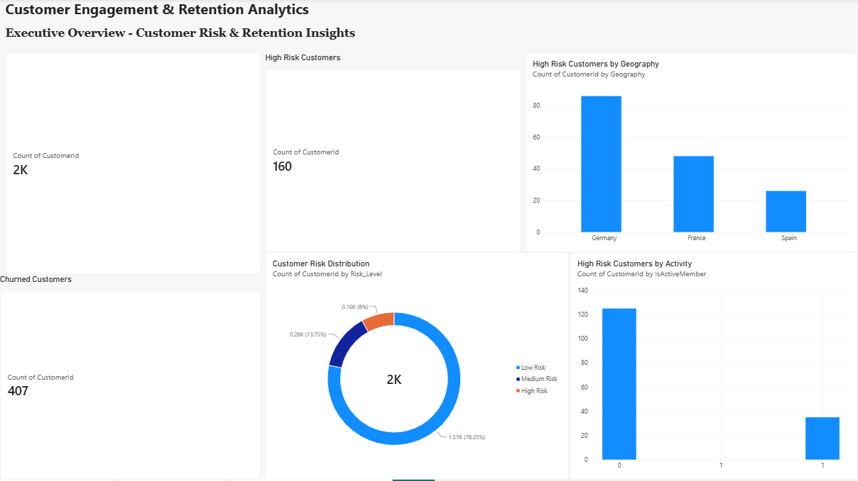
Figure: Power BI Executive Overview Dashboard
The first page, Executive Overview, provides a high-level summary of customer churn risk.
The main indicators presented on this page include:
- High-Risk Customers: 160
- Churned Customers: 407
- Low-Risk Customers: 1,565
- Medium-Risk Customers: 275
- High-Risk Customers: 160
The page also presents the distribution of high-risk customers across geography and activity status. Germany has the largest number of high-risk customers, with 86, followed by France with 48 and Spain with 26. The activity analysis shows that 125 high-risk customers are inactive, compared with 35 active customers.
This page provides management with a quick overview of the scale and distribution of customer retention risk.
2. Risk Analysis
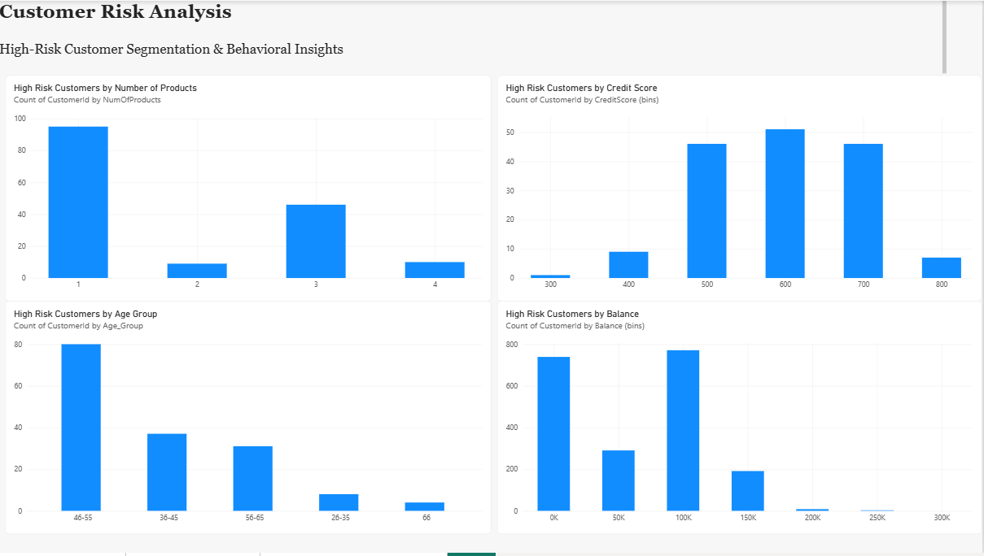
Figure: Power BI Risk Analysis Dashboard.
The second page, Risk Analysis, provides a more detailed examination of high-risk customers.
The dashboard includes visualizations showing high-risk customers according to:
- Number of products
- Credit-score range
- Age group
- Balance range
- Tenure
- Gender
- Product utilization and activity status
The product analysis shows that 95 high-risk customers have one product, while 46 have three products and 10 have four products. The age analysis highlights the concentration of high-risk customers in the 46–55 age group, which contains 71 customers.
The combination of product utilization and activity status provides an additional perspective. 83 high-risk customers were inactive and had one product, representing the largest subgroup in this analysis.
3. Customer Risk Profile
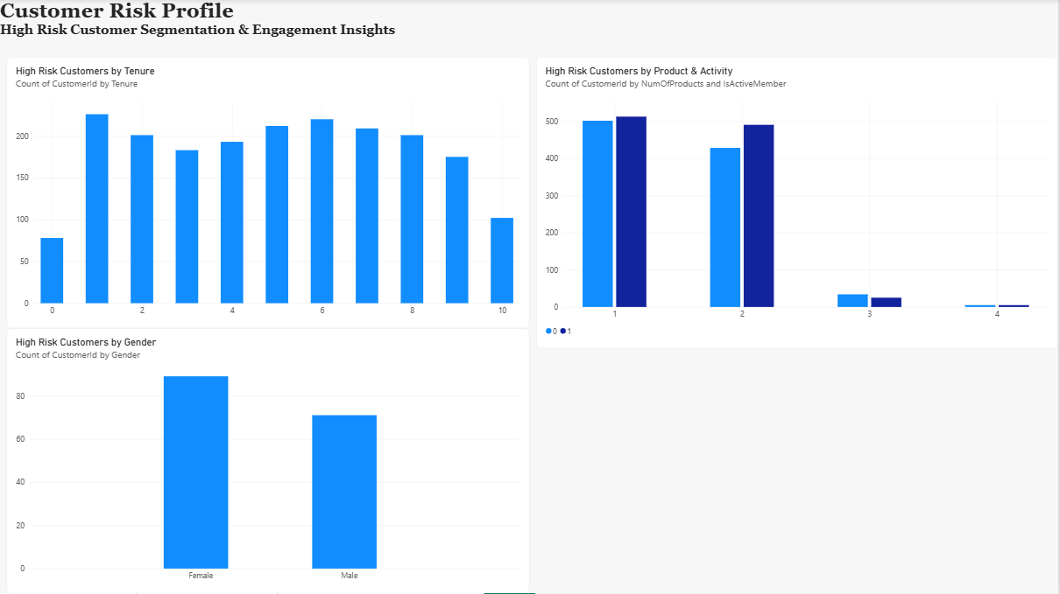
Figure: Power BI Customer Risk Profile Dashboard.
The third page, Customer Risk Profile, focuses on the characteristics of high-risk customers in greater detail.
The dashboard provides breakdowns of high-risk customers by:
- Tenure
- Gender
- Number of products
- Activity status
This page enables users to examine the composition of the high-risk segment and identify customer groups that may require greater retention attention.
12.4 Business Use of the Dashboard
The dashboard converts the machine learning results into an accessible decision-support tool. Instead of relying only on model metrics, management can use the dashboard to understand where high-risk customers are concentrated and what characteristics they share.
For example, the dashboard can help retention teams prioritize:
- High-risk customers identified by the predictive model.
- Inactive customers requiring re-engagement.
- One-product customers for appropriate product-utilization opportunities.
- Customers in Germany, where the highest number of high-risk customers was observed.
- Customers aged 46–55, which represents the largest age group within the high-risk segment.

Discussion
The findings of this study demonstrate that customer churn in the banking sector is associated with a combination of customer demographics, financial characteristics, engagement levels, and product utilization. Rather than relying on a single factor, the study combines exploratory analysis and machine learning to identify patterns that can support customer retention decisions.
The overall churn rate in the dataset was 20.37%, with 2,037 customers having exited compared with 7,963 retained customers. The exploratory analysis showed considerable variation in churn across different customer groups. In particular, inactive customers recorded a churn rate of 26.85%, compared with 14.27% among active customers. This difference highlights the importance of customer engagement when assessing retention risk.
Product utilization also showed an important relationship with churn. Customers holding one product had a churn rate of 27.71%, whereas customers with two products had a considerably lower churn rate of 7.58%. However, customers with three and four products showed very high churn rates. These groups were relatively small, so the unusually high percentages should be interpreted carefully. The results suggest that product count should be examined together with customer engagement and other characteristics rather than being treated as an independent cause of churn.
Geographic differences were also evident. Germany recorded the highest churn rate at 32.44%, almost twice the rates observed in France (16.15%) and Spain (16.67%). This pattern was also reflected in the high-risk segment, where Germany accounted for 86 of the 160 high-risk customers. This indicates that geographic segmentation may be useful when prioritizing further investigation and retention activities.
Age emerged as particularly important in the analysis. Customers aged 46–55 had a churn rate of 50.57%, while the 56–65 group recorded 48.32%. Age was also the most important feature in the Random Forest model, with an importance score of 0.2506. This consistency between EDA and machine learning strengthens the finding that age contains substantial predictive information in this dataset. However, the relationship should be interpreted as predictive rather than causal.
The machine learning comparison further demonstrated the value of using a non-linear ensemble model for churn prediction. Random Forest outperformed Logistic Regression across all reported evaluation measures, achieving 86.15% accuracy and 85.53% ROC-AUC, compared with 80.80% accuracy and 77.48% ROC-AUC for Logistic Regression. The difference was particularly relevant for churn identification, as Random Forest achieved a recall of 43.73% at the default 0.50 threshold compared with only 18.67% for Logistic Regression.
However, accuracy alone was not sufficient for the retention objective. The threshold analysis showed that reducing the Random Forest classification threshold to 0.30 increased recall to 65.11% and produced an F1-score of 62.13%. Although precision decreased to 59.42%, the lower threshold allowed the model to identify a larger proportion of customers who actually churned. This demonstrates the importance of selecting a classification threshold according to the business objective rather than automatically using the conventional 0.50 threshold.
The risk segmentation provided a practical interpretation of the model output. Among the 2,000 test customers, 160 were classified as high risk, 275 as medium risk, and 1,565 as low risk. The high-risk group was characterized by a high proportion of inactive customers, with 125 of the 160 high-risk customers being inactive. The largest age group within this segment was 46–55, with 71 customers. These findings provide a basis for prioritizing retention resources toward customers who combine higher predicted churn probability with relevant behavioral characteristics.
The study also demonstrates the value of integrating machine learning with business intelligence. The Power BI dashboard converts the model results into an accessible format through the Executive Overview, Risk Analysis, and Customer Risk Profile pages. This enables users to examine the distribution of high-risk customers by geography, activity, age, product utilization, balance, credit score, tenure, and other characteristics.
Overall, the findings suggest that an effective retention framework should combine predictive risk scoring with customer engagement and product-utilization analysis. The Random Forest model provides the predictive component, while the EDA and Power BI dashboard provide the context required to interpret and act upon those predictions. Nevertheless, the results represent associations within the available dataset and should not be interpreted as evidence that any individual characteristic directly causes customer churn.

Limitations
Although the study provides useful insights into customer churn and retention, several limitations should be considered when interpreting the findings.
1. Dataset Limitations
The analysis was conducted using a dataset containing 10,000 customer records and 14 variables. The available variables provide information about customer demographics, financial characteristics, product usage, and activity, but they do not capture all factors that may influence customer churn. Variables such as customer satisfaction, service quality, complaints, transaction frequency, digital banking usage, and interactions with customer support were not available in the dataset.
2. Limited Time Dimension
The Year variable was constant at 2025 and therefore did not provide meaningful variation for analysing changes over time. As a result, the study could not examine customer behaviour across multiple years or identify whether churn patterns were changing over time.
3. Model Performance Limitations
Although Random Forest performed better than Logistic Regression, it did not identify all churned customers. At the selected probability threshold of 0.30, the model achieved a recall of 65.11%, meaning that some customers who eventually churned were still not identified as high-risk.
Therefore, the model should be considered a decision-support tool rather than a completely accurate churn prediction system.
4. Small Customer Groups
Some categories contained relatively few observations. In particular, customers with three or four products represented a small proportion of the dataset but showed extremely high churn rates. Similarly, the 200K+ balance group contained only 34 customers.
These small groups can produce unstable percentages, so their results should not be generalized without further validation using a larger sample.
5. Threshold Selection
The study selected a 0.30 probability threshold because the retention objective placed greater importance on identifying potential churners. However, threshold selection involves a trade-off between precision and recall. A different threshold may be more appropriate depending on the bank's intervention costs, available resources, and tolerance for false-positive retention cases.
6. Interpretation of Feature Importance
Random Forest feature importance identifies variables that were useful for prediction, but it does not establish causal relationships. For example, the high importance of age does not mean that age itself causes customers to leave the bank. Further statistical or causal analysis would be required to establish such relationships.
7. Generalizability
The findings are based on the specific customer dataset used in this study. Customer behaviour can vary across banks, countries, products, and time periods. Therefore, the results should be validated on additional and more recent customer data before being applied to a broader banking population.
8. Ethical Considerations
Customer risk scores should be used responsibly. Variables such as gender and demographic characteristics may reveal differences in observed churn patterns, but they should not be used to unfairly discriminate against customers. Retention decisions should consider relevant customer behaviour and business context alongside model predictions.
Future Scope
The present study provides a foundation for using machine learning and customer analytics to support banking customer retention. However, the framework can be further developed by incorporating additional data, advanced analytical techniques, and continuous model monitoring.
1. Incorporation of Customer Behavioral Data
Future studies can include detailed behavioral variables such as transaction frequency, average transaction value, digital banking usage, login frequency, customer complaints, service interactions, and response to marketing campaigns. These variables could provide a more detailed understanding of customer engagement and improve churn prediction.
2. Use of Longitudinal Customer Data
The current analysis is based on a single-period dataset. Future research can use customer data collected over multiple months or years to examine changes in customer behavior before churn occurs. This would allow the identification of early warning signals and changing engagement patterns.
3. Advanced Machine Learning Models
Future research can compare Random Forest with other advanced techniques such as Gradient Boosting, XG Boost, Light GBM, Support Vector Machines, and neural networks. Model performance can be compared using recall, F1-score, ROC-AUC, and business-oriented measures to determine the most suitable approach for retention prediction.
4. Explainable Machine Learning
Future implementations can incorporate explainable AI techniques such as SHAP or LIME to provide customer-level explanations for individual churn predictions. This would help retention teams understand why a particular customer has been classified as high risk and select more appropriate interventions.
5. Real-Time Churn Monitoring
The current Power BI dashboard provides a static analytical view of the available customer data. Future systems could integrate continuously updated customer information so that churn probabilities and risk categories are refreshed regularly. This would allow organizations to identify changes in customer risk at an earlier stage.
6. Evaluation of Retention Campaigns
Future research should move beyond predicting churn and evaluate whether retention interventions actually reduce churn. For example, high-risk customers could be divided into intervention and control groups to measure the effectiveness of different retention strategies.
7. Cost-Sensitive Retention Decisions
Future studies can incorporate the financial cost of customer churn and the cost of retention campaigns. Instead of simply maximizing predictive performance, models could be optimized according to the expected financial value of retention, helping organizations determine which customers are economically worthwhile to target.
8. Continuous Model Validation
Customer behavior and banking conditions can change over time. Therefore, future implementations should regularly retrain and validate the predictive model using newer customer data. Monitoring model performance can help identify model drift and ensure that the predictions remain reliable.
Conclusion
This study demonstrates how customer engagement, product utilization, and machine learning can be combined to support customer retention in the banking sector. Using a dataset of 10,000 European banking customers, the study examined customer characteristics and behavioral patterns associated with churn and developed a predictive framework for identifying customers at higher risk of leaving.
The exploratory analysis identified meaningful differences in churn across several customer groups. Overall, 20.37% of customers had exited, while 79.63% were retained. Inactive customers recorded a higher churn rate of 26.85% compared with 14.27% among active customers. Geographic differences were also observed, with Germany recording the highest churn rate at 32.44%. Customers aged 46–55 and 56–65 showed particularly high churn rates, while product utilization also displayed substantial differences across groups.
Two machine learning models, Logistic Regression and Random Forest, were developed and evaluated. Random Forest provided stronger predictive performance, achieving 86.15% accuracy and 85.53% ROC-AUC, compared with 80.80% accuracy and 77.48% ROC-AUC for Logistic Regression. The Random Forest model was therefore selected as the primary predictive model.
Because customer retention requires effective identification of potential churners, probability threshold analysis was also conducted. Reducing the classification threshold to 0.30 increased recall to 65.11% and produced an F1-score of 62.13%. This allowed the model to identify a larger proportion of customers who actually churned and was therefore more aligned with the retention objective.
The model-generated probabilities were subsequently used to create customer risk segments. Within the 2,000-customer test set, 160 customers were classified as high risk, 275 as medium risk, and 1,565 as low risk. The high-risk segment contained 125 inactive customers, indicating that customer engagement is particularly relevant when interpreting predicted churn risk. Germany and the 46–55 age group also represented substantial portions of this segment.
Finally, the findings were translated into a Power BI dashboard consisting of an Executive Overview, Risk Analysis, and Customer Risk Profile. The dashboard provides a practical interface for examining customer risk across geography, activity, age, products, balance, credit score, tenure, and other characteristics.

References
Boozary, P., Sheykhan, S., Ghorban Tanhaei, H., & Magazzino, C. (2025). Enhancing customer retention with machine learning: A comparative analysis of ensemble models for accurate churn prediction. International Journal of Information Management Data Insights, 5(1), 100331. https://doi.org/10.1016/j.jjimei.2025.100331
Maduna, M., Telukdarie, A., Munien, I., Onkonkwo, U., & Vermeulen, A. (2024). Smart customer churn management system using machine learning. Procedia Computer Science, 237, 552–558. https://doi.org/10.1016/j.procs.2024.05.139
Öztemel, E., & Işık, M. (2026). The customer churn prediction with artificial intelligence approaches in banking sector. Procedia Computer Science, 280, 874–880. https://doi.org/10.1016/j.procs.2026.04.109
Prabhadevi, B., Shalini, R., & Kavitha, B. R. (2023). Customer churning analysis using machine learning algorithms. International Journal of Intelligent Networks, 4, 145–154. https://doi.org/10.1016/j.ijin.2023.05.005
Rahman, M., & Vasimalla, K. (2020). Machine Learning Based Customer Churn Prediction In Banking. 2020 4th International Conference on Electronics, Communication and Aerospace Technology (ICECA).
Singh, P. P., Anik, F. I., Senapati, R., Sinha, A., Sakib, N., & Hossain, E. (2024). Investigating customer churn in banking: A machine learning approach and visualization app for data science and management. Data Science and Management, 7(1), 7–16. https://doi.org/10.1016/j.dsm.2023.09.002
Tékouabou, S. C. K., Gherghina, Ș. C., Toulni, H., Mata, P. N., & Martins, J. M. (2022). Towards explainable machine learning for bank churn prediction using data balancing and ensemble-based methods. Mathematics, 10(14), 2379. https://doi.org/10.3390/math10142379
Văduva, A.-G., Oprea, S.-V., Niculae, A.-M., Bâra, A., & Andreescu, A.-I. (2024). Improving churn detection in the banking sector: A machine learning approach with probability calibration techniques. Electronics, 13(22), 4527. https://doi.org/10.3390/electronics13224527
Xie, Y., Li, X., Ngai, E. W. T., & Ying, W. (2009). Customer churn prediction using improved balanced random forests. Expert Systems with Applications, 36(3), 5445–5449. https://doi.org/10.1016/j.eswa.2008.06.121

